12 NIGHT BOTSWANA FAMILY SAFARI
SUITABLE FOR CHILDREN AGED 6 YEARS AND OLDER
CHOBE, OKAVANGO DELTA MOREMI AND MAKGADIKGADI PANS

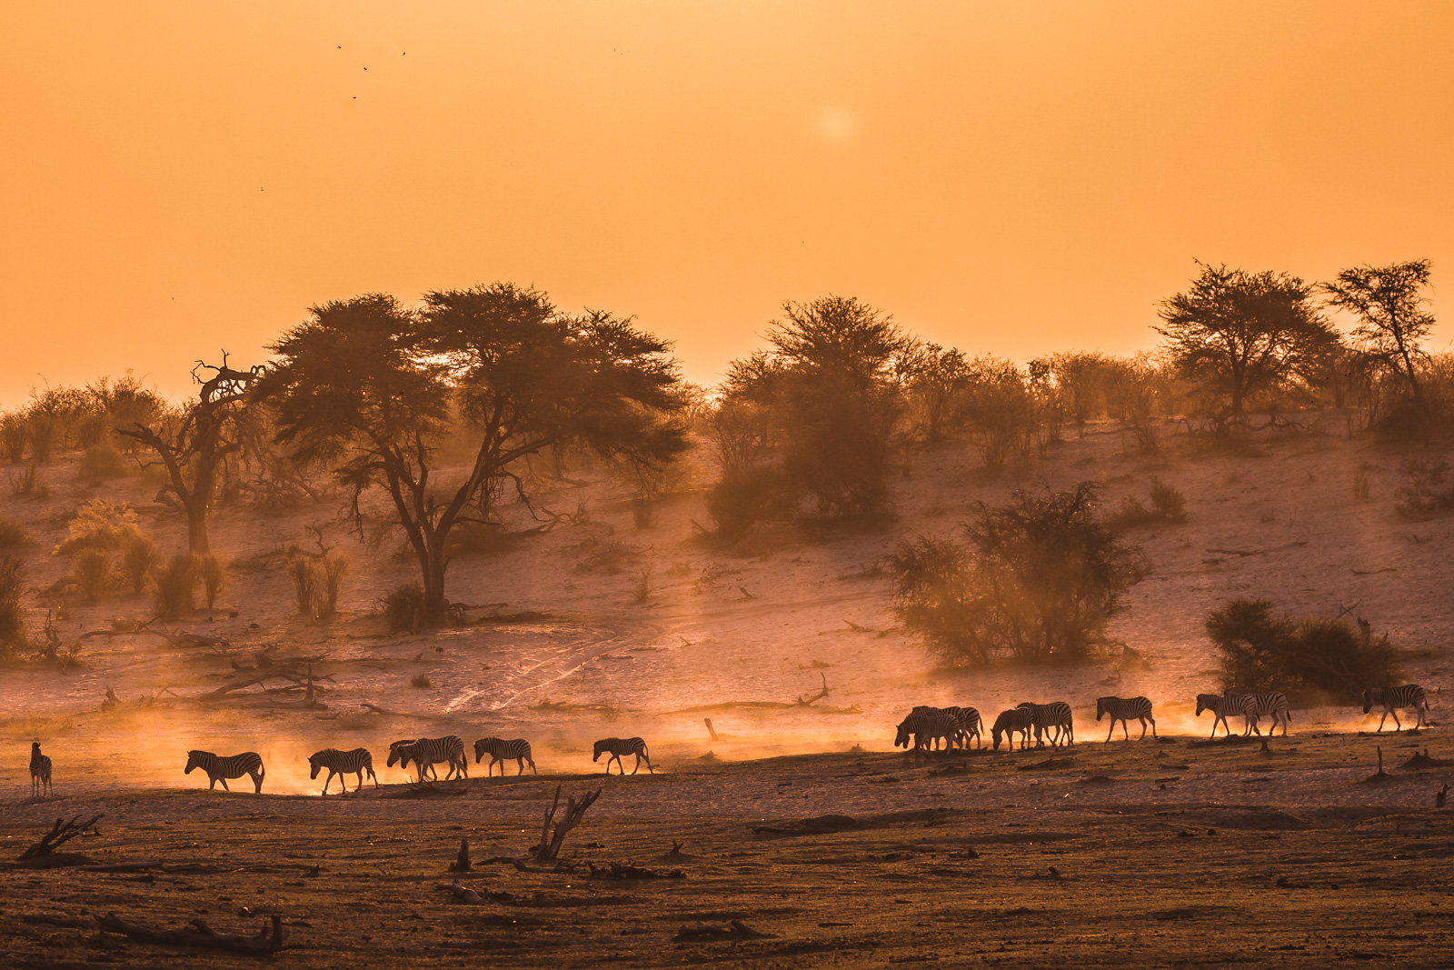

This 12 night Ultimate Family Safari allows your family to experience a choice and combination of four key ecosystems and environments within Botswana on a fun filled adventure of discovery suited and focused on the specific needs of a family safari. All the lodges have a swimming pool – essential for that midday cool down!

Your days will be spent on safari exploring the wild, pristine wilderness of Botswana and there are also opportunities to engage culturally with local communities and their children. Stay in intimate, small and exclusive lodges allowing for personalised service and attention to detail. Take your kids on a safari of a lifetime – grandparents welcome too!
DAY ONE
On arrival into Kasane International Airport you will be met and transferred to Chobe Game Lodge for 3 nights on an all-inclusive basis. The lodge is the perfect place to allow your family to rest and relax after your long international flight and a visit to Victoria Falls has been arranged during your stay.

Chobe Game Lodge is designed as a haven of peace and privacy – where relaxation is effortless and you can enjoy your own space. With six comfortably furnished viewing decks, a riverside boma, two bars, six different lounges and four dining locations, a comfy chair or lounger is never far away, each with a different perspective on the wilderness that surrounds the lodge. A large swimming pool provides welcome relief during hot afternoons and there is always a waiter on hand to bring you refreshments from the bar.

The Lodge offers a choice of land or water-based activities and the most complete game experience in the Chobe National Park. Early-morning and late-afternoon game drives are conducted by our expert guides in open-sided 4×4 vehicles to ensure maximum visibility of Chobe National Park’s spectacular scenery and abundant wildlife. Meanwhile, riverside game viewing may be done from small and highly manoeuvrable boats, perfect for morning or sunset cruises.

Chobe’s diverse wildlife includes some of the largest concentrations of elephant in Africa. During the dry season these large herds, as well as vast herds of buffalo, congregate on the fertile flood plains along the Chobe River to drink, bathe and play. There are frequent sightings of lion, African wild dog, puku, red lechwe, sable, giraffe and roan antelope.

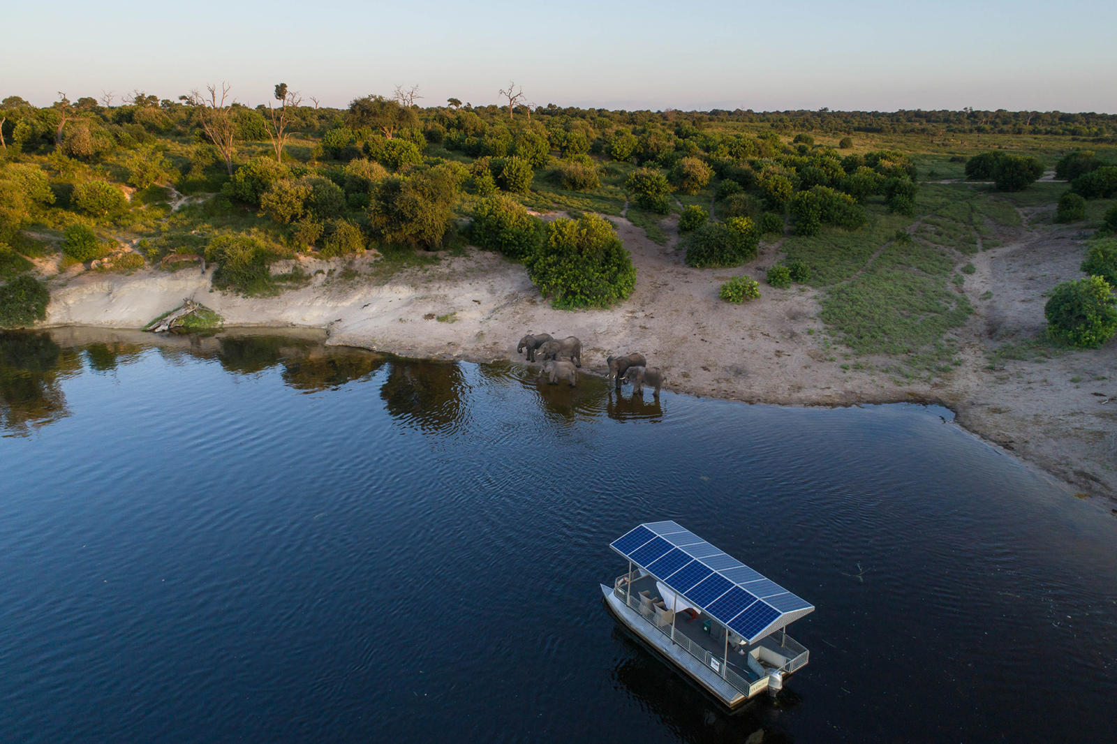

DAY FOUR
Today you will transfer back to Kasane international Airport in time to check in for your light aircraft flight down to the Okavango Delta. On arrival you will be met and transferred to Xugana Island Lodge for 3 nights on an all-inclusive basis.

Xugana Island Lodge is situated on a private concession and takes full advantage of this magnificent site. An expansive deck and al fresco dining area overlooks the vast, pristine body of water that makes up the permanent Okavango Delta.

The lodge accommodates only sixteen guests in large, raised, reed and thatch lagoon-facing chalets, with en-suite facilities and private viewing decks optimally placed on the shaded fringe of the island. The lounge, bar and dining areas are set back under the Ebony and African Mangosteen tree canopy in open-sided thatched structures, and the swimming pool, located within the mature gardens in the centre of the island, is a perfect place to relax.

Xugana Island Lodge is in a private concession offering a range of activities giving you the chance to experience a true Okavango Delta safari. All activities are conducted by experienced professional guides. Explore the crystal-clear waterways by mokoro (traditional dugout canoe) or motorboat for the chance to enjoy the magnificent variety of bird, plant and reptile species found in the area.

Your experienced guide will also take you on a guided nature walk on surrounding islands in the concession, giving you the chance to experience nature up close and personal. Day and night game drives are also available within the private concession for a chance to search for the prolific wildlife found in the area. Catch and release fishing for bream and tiger fish is also offered as an added activity at the lodge (season dependent).

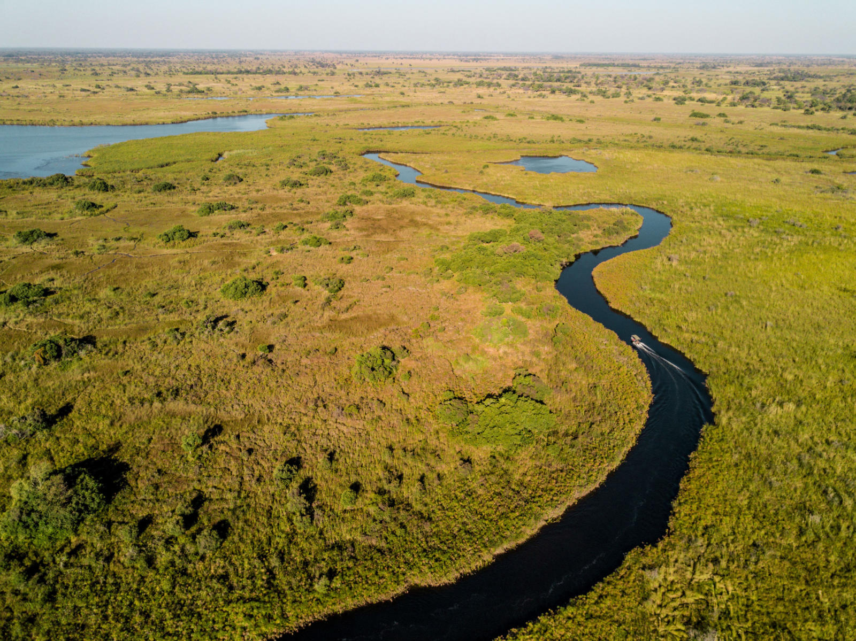

DAY SEVEN
Today you will be transferred by light aircraft to The Moremi Game Reserve. On arrival you will be met and transferred to Camp Xakanaxa for 3 nights on an all-inclusive basis.
Camp Xakanaxa (pronounced Ka-ka-na-ka) is perched on the banks of the Khwai River on the Xakanaxa Lagoon, in the heart of the Moremi Game Reserve. The camp accommodates twenty-four guests in eleven spacious all-canvas, classic Meru-style luxury safari tents and one two bedroom family tent, each with en suite showers, hand basins and toilet facilities. Situated around the fringe of the lagoon, every tent has a private viewing deck with comfortable loungers.

In camp, a relaxed and friendly atmosphere together with personalised and caring service evokes a feeling of coming home. The stylish main buildings extend over the Khwai River and are set on raised platforms to maximise the views over the surrounding lagoons and islands. The elegant lounge and dining rooms, built of local timber, reed and thatch, feature a small library, expansive sundeck, plunge pool and sala with day bed. The fire-deck extends over the Khwai River and creates an enchanting environment in which to relax after dinner. There is also a large pool with elevated sun deck in the expansive grounds.

The ancient riverine forests, open savannah, serpentine channels and seasonal floodplains that surround the camp make for a varied habitat of exceptional fauna and flora. The camp is one of few offering a year-round land and water game-viewing experience, in open 4×4 safari vehicles or powerboats. The diverse habitat ensures prolific sightings of Elephant, Buffalo, Hyena, Giraffe, Hippo, Wildebeest, Kudu, Lechwe, Lion and Leopard, among many others. Birding is spectacular, especially in the spring and summer months when the migrants are breeding.

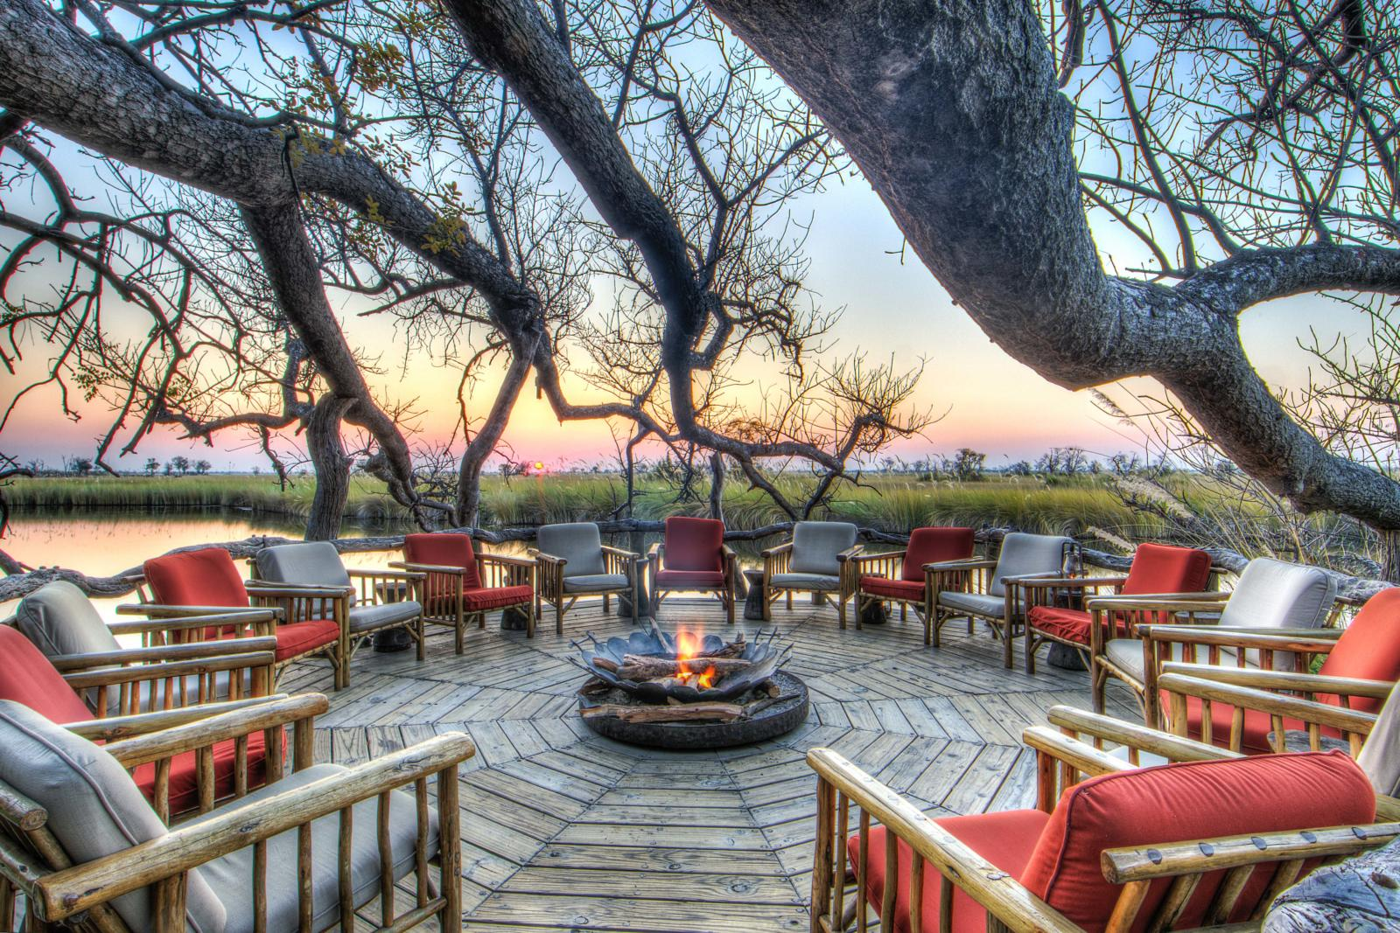

DAY TEN
Today you will transfer back to the airstrip in time for your light aircraft down to the Makgadikgadi Pans National Park where you will be met and transferred to Leroo La Tau for 3 nights on an all-inclusive basis.

The Makgadikgadi Pans National Park stretches away from the banks of the Boteti River, through its hinterland of scrub and grassland. The river and the nutrient-rich western grasslands supply the essential water and sustenance for the herds that inhabit the park.
Leroo La Tau is situated on the western bank of the Boteti River, north-west of Khumaga village, about 140 kilometres south-east of Maun. The river’s eastern bank forms the boundary of the Makgadikgadi Pans National Park. The Boteti River is the main outflow of the Okavango Delta, collecting the water that flows past Maun, then continuing about 250 km south-eastwards, finally ending at Lake Xau on the extreme south-western edge of the great Makgadikgadi salt pans.

The lodge features twelve luxurious thatched and glass-fronted suites with en-suite bathrooms, each unit raised on a wooden platform. The main lounge and dining area, with its inviting wooden and thatch finish, allows you to relax at the bar while listening to the wide variety of night sounds so characteristic of the African bush. Alternatively you can lounge around the swimming pool or enjoy the panoramic river vista from the game-viewing hide built into the bank of the river.

The lodge offers guided game drives in the Makgadikgadi Pans National Park focusing on the exceptional wildlife sightings along the Boteti River. Depending on the water level, boat activities are also provided. Optional cultural excursions can be arranged to Khumaga Village as well as day trips to Nxai pan and Baines Baobabs (three night stay only).

Leroo La Tau translates as ‘lion’s paw’ but, although the surrounding area features abundant Lion, Zebra and Wildebeest, it also boasts Chobe Bushbuck, Leopard, Cheetah, Brown and Spotted Hyena, Impala, Kudu, Jackal, Porcupine, Genet and Caracal, to name but a few.

Please note: Owing to their remote location within the Makgadikgadi Pans National Park, the Makgadikgadi Pans themselves are not visited on daily scheduled activities from Leroo La Tau.

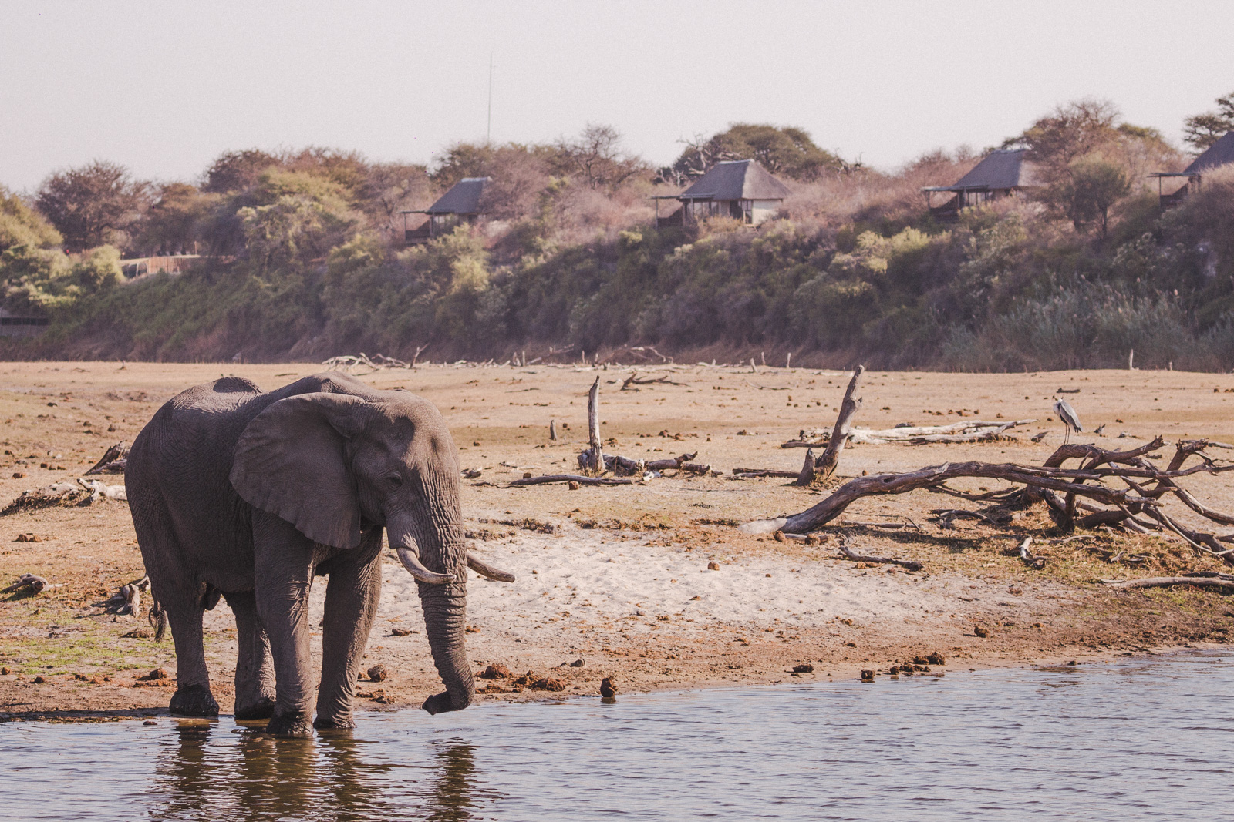

DAY THRITEEN
Today you will be transferred back to the airstrip in time for your light aircraft flight to Maun. On arrival you will be met and assisted to check-in for your international flight home.
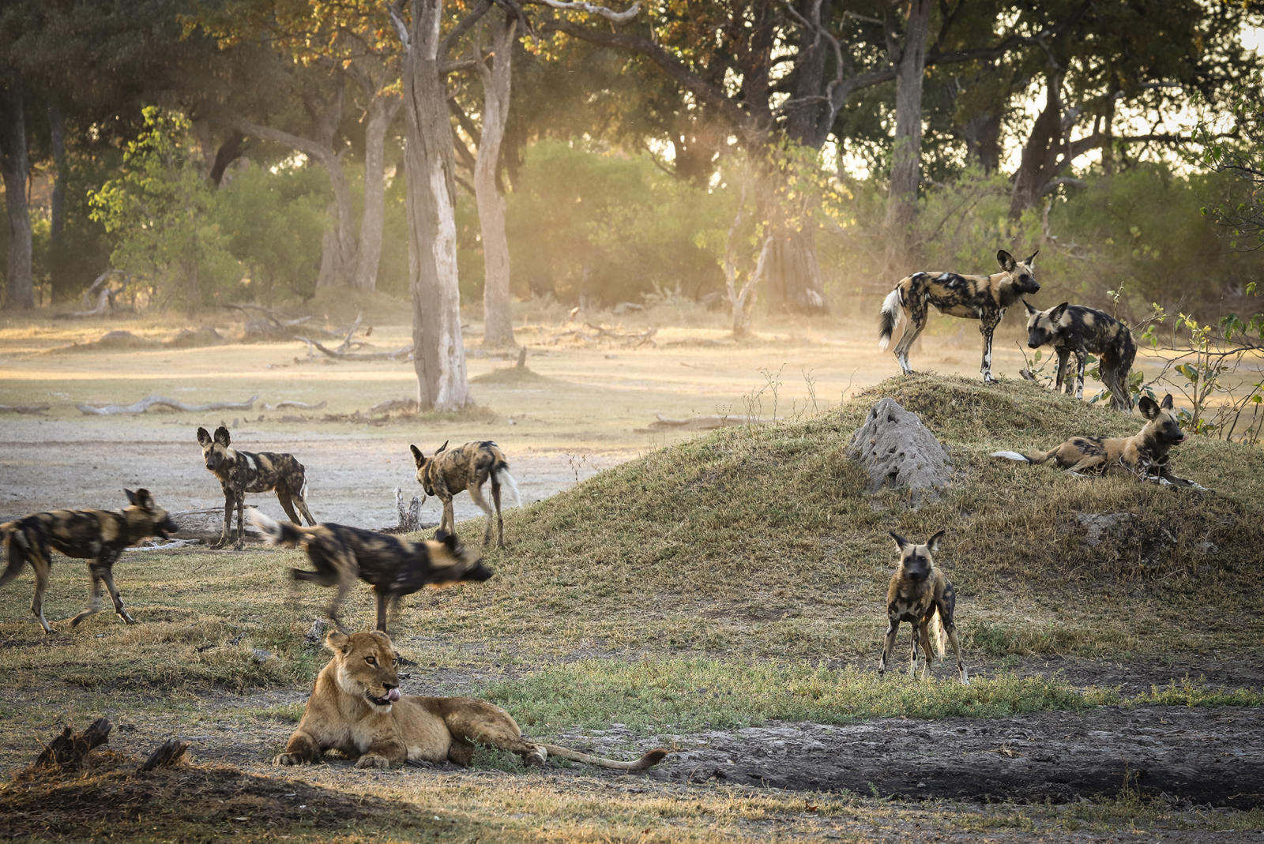

You can extend you safari by enjoying some time at Victoria Falls at the beginning of your adventure, more time on safari or perhaps extending your journey to Cape Town at the end. This safari is tailor made and we can adjust the number of nights and the lodges/camps to suit your budget and interests – please ask!

TRACKS SAFARIS – WE GET YOU CLOSER TO AFRICA!

