

12 NIGHT SOUTH LUANGWA NATIONAL PARK &
LIKOMA ISLAND ON LAKE MALAWI

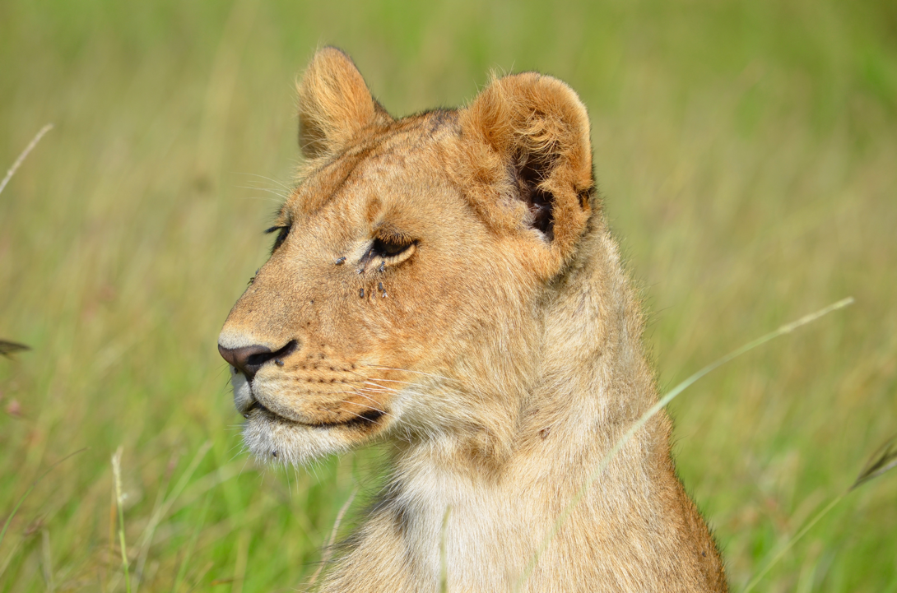

This 12 nights bush and beach package offers an exciting combination of a wildlife safari in the South Luangwa National Park with a relaxing beach stay on a remote island on Lake Malawi.

The first days are spent at Kafunta River Lodge in South Luangwa, offering the opportunity to discover the game rich Mfuwe area. Game viewing activities at Kafunta River Lodge include game drives in open vehicles along with unique night drives which offer the opportunity to view nocturnal animals.

The central location of Kafunta River Lodge allows us to explore vast areas of South Luangwa National Park. While at the lodge you can relax on the privacy of your viewing deck or by taking a swim in the infinity pool while keeping an eye on the elephants drinking at the waterhole. The lodge also features the only natural hot spring tub of Mfuwe, an intimate wellness spa as well as a small gym.

After Kafunta River Lodge you will transfer down to Island Bush camp for one night in a remote and simple bush camp with views over the Luangwa River before transferring to Three Rivers Camp for 2 nights. The bush camps are about 2 to 3 hour’s drive south of Kafunta in remote wilderness.

After your stay at the bush camps you will return to Kafunta River Lodge for 2 nights to enjoy more game drives in the area. Your itinerary will then take you to Malawi with a flight from Mfuwe to Lilongwe to enjoy 4 nights on the shores of Lake Malawi where you will be able to relax on the white sandy beaches or participate in the numerous water activities.

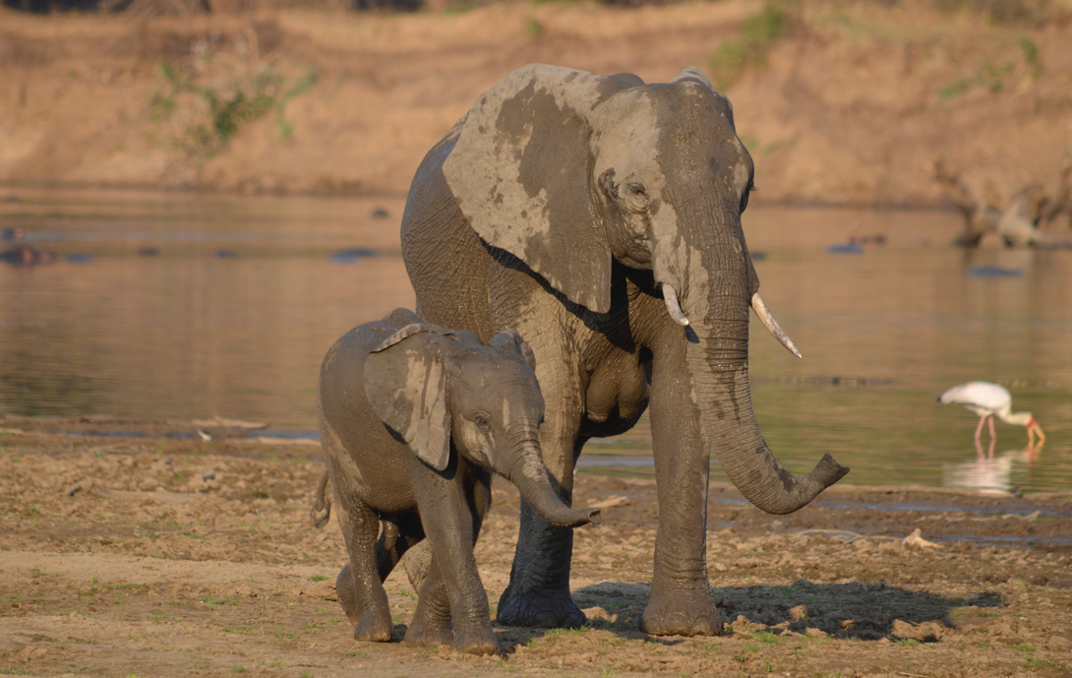

DAY ONE
On arrival into Lusaka International Airport you will be met and assisted to board your flight to Mfuwe with Proflight which takes just over an hour. On arrival into Mfuwe airport you will be met by Kafunta Safaris and transferred to Kafunta River Lodge for 3 nights on an all-inclusive basis.

The drive from Mfuwe Airport to Kafunta River Lodge is around 45 minutes and you will pass through villages and farming areas on the way to the lodge. Depending on your arrival time you will participate in the afternoon safari leaving the lodge at 15h30.

Kafunta River Lodge has just 8 safari chalets which stand on raised wooden platforms and have thatched roofs and private viewing decks. They are pleasantly decorated to match the local style. We also have two spacious luxury suites with extra-large ensuite bathrooms. Each suite features a cosy mezzanine with additional day beds and an open balcony. All the rooms have comfortable sitting areas with coffee and tea facilities and a small fridge stocked with refreshing drinks.

DAYS TWO AND THREE
Enjoy an early breakfast and depart for your morning game drive at around 06h30. You will be back at the lodge around 10h00 in time for brunch. Relax at the pool, book a spa treatment or enjoy a siesta on your viewing deck before meeting for afternoon tea at 15h00. The afternoon game drive departs at 15h30 and returns at 19h30 in time for drinks and dinner.

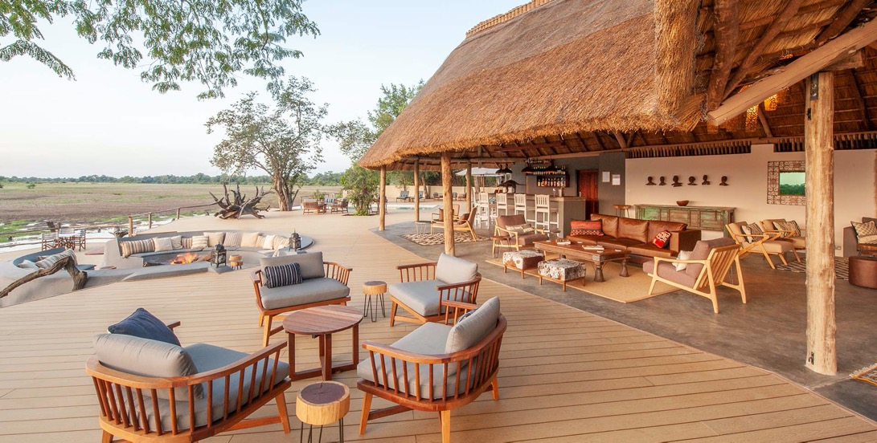

DAY FOUR
Today you will participate on the morning game drive at Kafunta River Lodge. After brunch at the lodge you will depart for the 2 to 3 hour transfer to Island Bush Camp for one night on an all-inclusive basis. On arrival you will be welcomed by the camp staff and given the chance to settle in your chalet.

You will be taking your sundowner with your guide at the camp and relax by the fireplace before an early dinner and a night under the stars - each tent has its own private sleep out, safely connected to the tent for convenient access day and night. Spend a night on the plush star beds, surrounded only by the sights and sounds of the African bush.

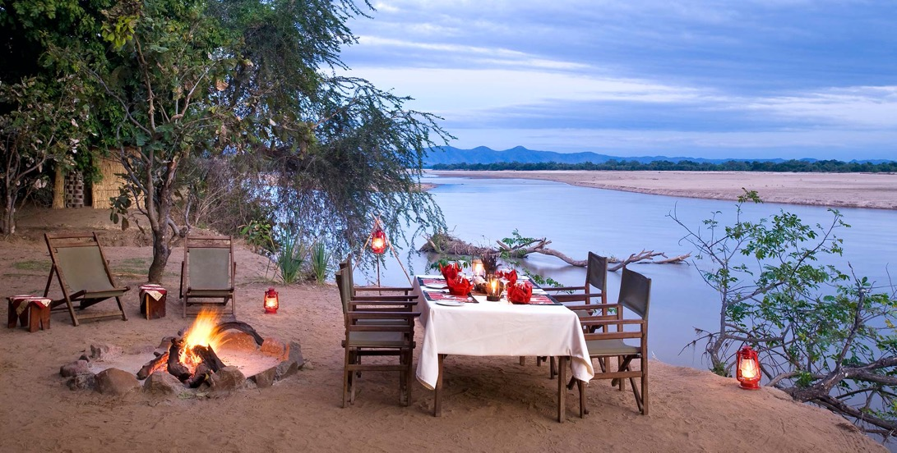
Island Bush Camp offers rustic open-sided huts built on stilts that ensure safety from wild animals while providing an unlimited view of the Luangwa River. Each of the 5 chalets has its own ensuite bathroom, with running water, flushing toilets and hot showers. The camp is the base for the daily walking safaris.

DAY FIVE
This morning you will wake early and after a hot drink around the campfire before setting off on your walking safari. You have the option of either walking to your next camp with your luggage travelling by road or a shorter walk with brunch at Island Bush Camp before transferring by road to Three Rivers Camp.

The Luangwa Valley is one of the few places in Africa where it is possible to walk in the wilderness and really gets you closer to Africa. Under the guidance of your professional guide and an armed national park scout you have the opportunity to safely discover the secrets of the African bush on foot. Tea and coffee is usually enjoyed in the bush before heading back to camp.

If you don’t opt to walk to the next camp you will arrive back into camp in time to have a shower and brunch before setting off to Three Rivers Camp for 2 nights on an all-inclusive basis. After a short rest you will meet for afternoon tea and your evening game drive.

Three Rivers Camp is ideally located between the Luangwa River and a wildlife-rich lagoon. The camp features 5 sumptuous tents decorated in earthy tones, each with a private viewing deck and separate platform where you can choose to sleep out at night. The ensuite bathroom offers the choice of an indoor or outdoor shower.

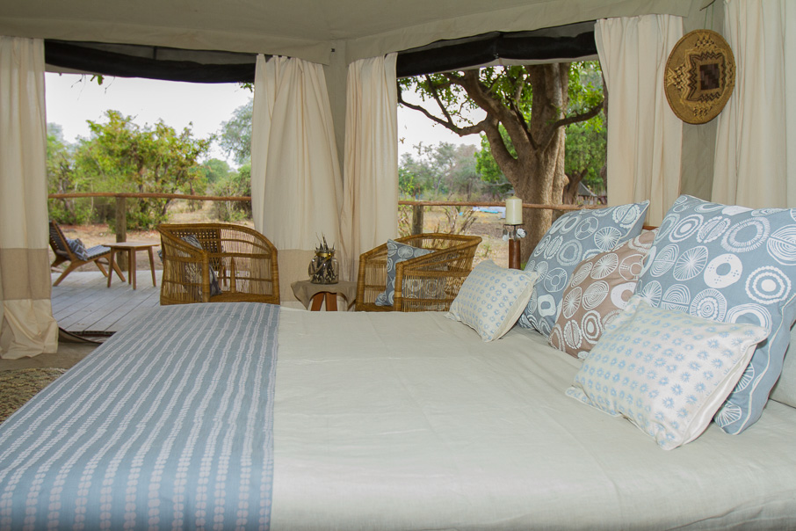

DAY SIX
You have the whole day to explore the area around Three Rivers Camp – activities include game drives in the South Luangwa National Park as well as bush walks around the camp area and along the river banks. Encounter elephants, giraffes, waterbuck and perhaps the relatively rare roan antelope, as well as lions, leopards and wild dogs.

DAYS SEVEN AND EIGHT
This morning you will have a short game drive or walk followed by an early brunch before returning to Kafunta River Lodge for two nights on an all-inclusive basis. You will be arriving at the lodge around 13h00 and you can relax before joining afternoon tea and the afternoon game drive. The next day is a normal day at Kafunta with morning and afternoon game drives in the South Luangwa National Park.

DAY NINE
This morning you will be transferred back to Mfuwe Airport with an optional stop at Project Luangwa craft shop or Tribal Textiles (to be scheduled in advanced - allow an extra 45 minutes) in time for your flight to Lilongwe (Malawi). On arrival you will go through customs before connecting to a short flight to Likoma Island. You are assisted through this process by a Ulendo Airlink representative - the flight from Mfuwe to Lilongwe to Likoma with Ulendo Airlink is around 2 1/2 hours in total.

Upon arrival at Likoma airstrip you will be met by Kaya Mawa and transferred to the lodge for 4 nights on a full board basis. The transfer to the lodge will be by boat and hopefully you will have enough time to settle into your room before enjoying your first Malawian sunset.

DAYS TEN, ELEVEN AND TWELVE
Over the next few days you can organise your beach holiday as you wish - activities here are varied and include swimming and snorkeling in the clear waters of the lake, kayaking, boat trips and sunset cruise, snorkeling or scuba diving and birding safaris, and more. You will also find a bar and restaurant where fine meals are served as part of the fully inclusive package. You can also choose to visit the island and its cathedral and pay a visit to the wonderful ladies of Katundu’s workshop.

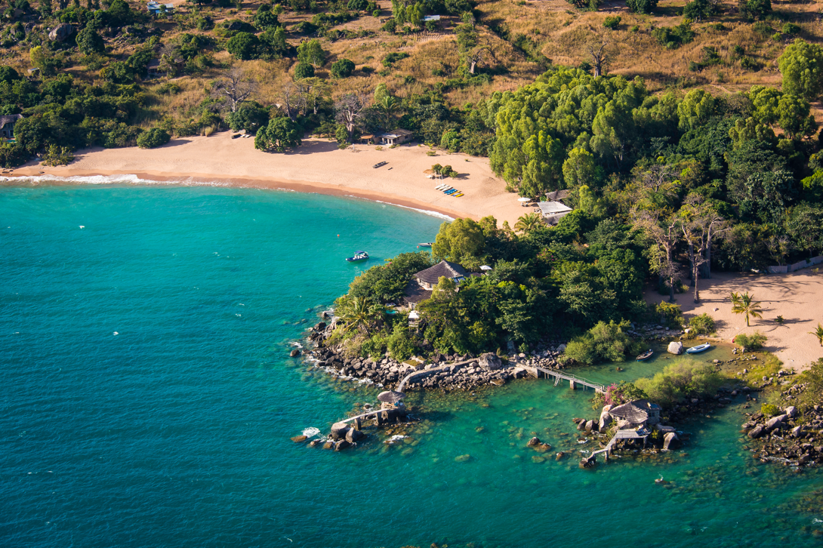
DAY THIRTEEN
This morning you will be transferred back to Likoma airstrip in time for your flight to Lilongwe where you will connect to your international departure. The flight from Likoma to Lilongwe with Ulendo Airline will be approximately 60 minutes and on arrival you will be met and assisted to check in for your international flight home.

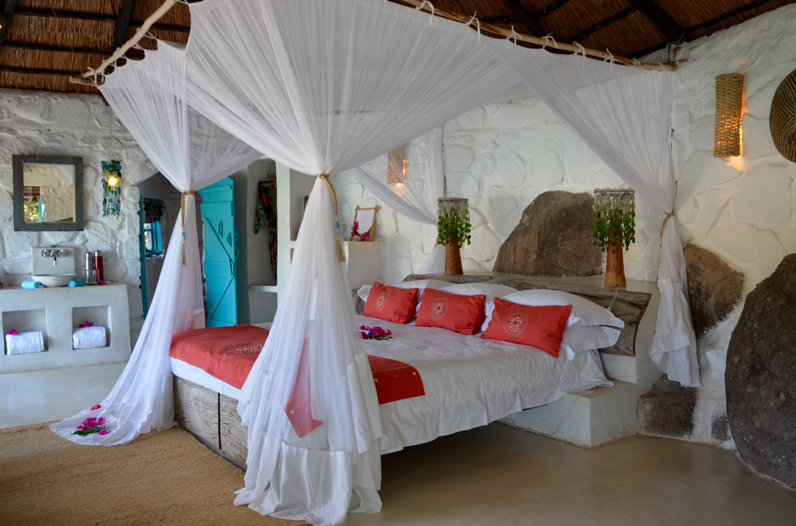

You can extend your Zambian adventure by enjoying a few days in the Lower Zambezi National Park or Victoria Falls in Zambia – or Mvuu Lodge in Liwonde National Park or Mkulumadzi Lodge in Majete National Park in Malawi – please ask!

TRACKS SAFARIS – WE GET YOU CLOSER TO AFRICA!



