
12 NIGHT SOUTHERN MALAWI EXPLORATION
Liwonde National Park, Thyolo, Zomba, Majete Wildlife Reserve, Mumbo Island, Lilongwe

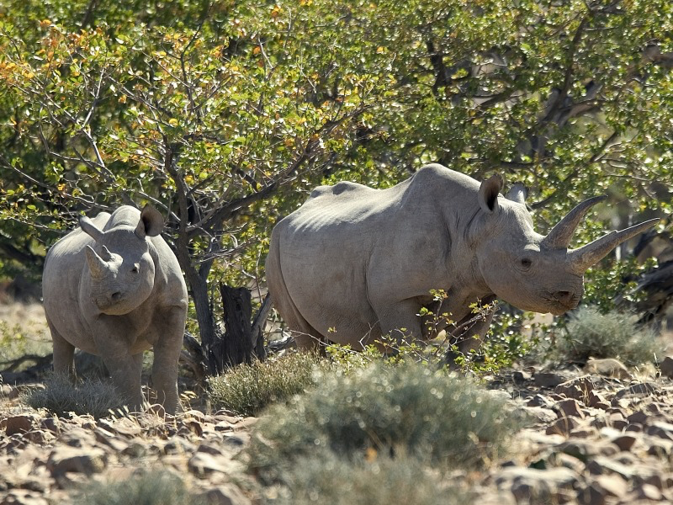
DAY ONE
Upon arrival in Lilongwe you will be transferred south to Mvuu Lodge via a four-hour drive along scenic roads.
Area and location: Expanding across an area of 548 sq km, Liwonde National Park is regarded as Malawi’s premier wildlife destination. Named after Chief Liwonde who had championed its protection the park harbours very diverse landscapes including swamps, deciduous woodlands, open grasslands, mopane and miombo woodlands as well as Palm savannah and numerous baobabs. The park has a healthy population of elephants, hippos and crocodiles. Waterbuck wade in lagoons and marshes, while the open savannah and hills of the interior attract antelopes such the elegant sable, impala and bushbuck. Rare sightings include black rhino, leopard, serval and the occasional lion. Nearly 400 bird species occur in the Park.
Accommodation: Renowned for providing exquisite safari experiences and unforgettable adventures, Mvuu Lodge is one of Malawi’s finest wilderness camps. Set in lush vegetation on the banks of a quiet lagoon, the lodge has 8 stunningly designed tents, each with a private viewing platform, luxurious furnishings and beautifully appointed bathrooms (including a unique outdoor shower). Your last night at Mvuu will be on the Star Beds platform located four kms north of the lodge. With a 180 degree view of the park’s floodplains, river and riverine thickets, the Star Beds provide an excellent game viewing opportunity and ‘back to nature’ experience.
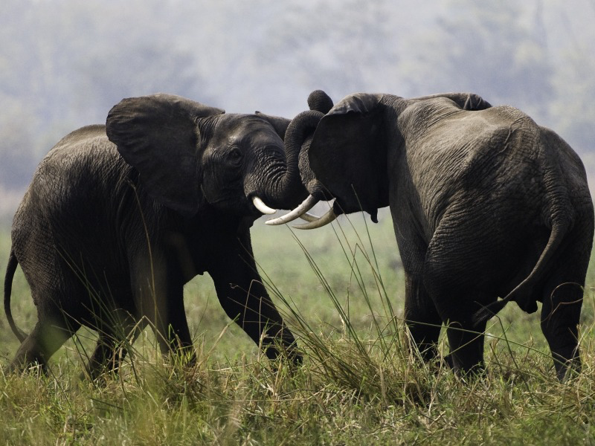
DAYS TWO AND THREE
During these two days, you will be able to explore the diverse wilderness and magnificent landscapes of Liwonde National Park, as well as enjoy various other activities.
Activities: On the first day of your stay at Mvuu Lodge you can join the daily evening game drive which takes place each afternoon. During the drive your guide will take you to popular game viewing spots within the park and will thereafter stop at a safe location for you to enjoy sundowners. On your return, you will be able to enjoy a wholesome meal on the lodge’s dining deck, which overlooks the Shire River.
On the following mornings you can opt for an early morning walk in place of a boat safari or you can choose to go on your boat safari slightly later in the morning. A boat safari on the Shire is considered one of the signature activities at Mvuu and offers you the chance to observe the park’s wildlife from a unique perspective.
You can also request to visit a local village during your stay, the nearby villages and local schools are located a short boat ride away and can be organised for guests who are interested in learning more about community development initiatives and traditional life in Liwonde. All meals can be enjoyed at the lodge, however you can also make the request for a special bush lunch or breakfast or choose to take a packed lunch with you if you are planning on opting for an afternoon game viewing activity.
DAY FOUR
After breakfast you will travel two hours by road to Huntingdon House in Thyolo. You can opt to enjoy a comprehensive tour of Zomba Town en-route to Thyolo.
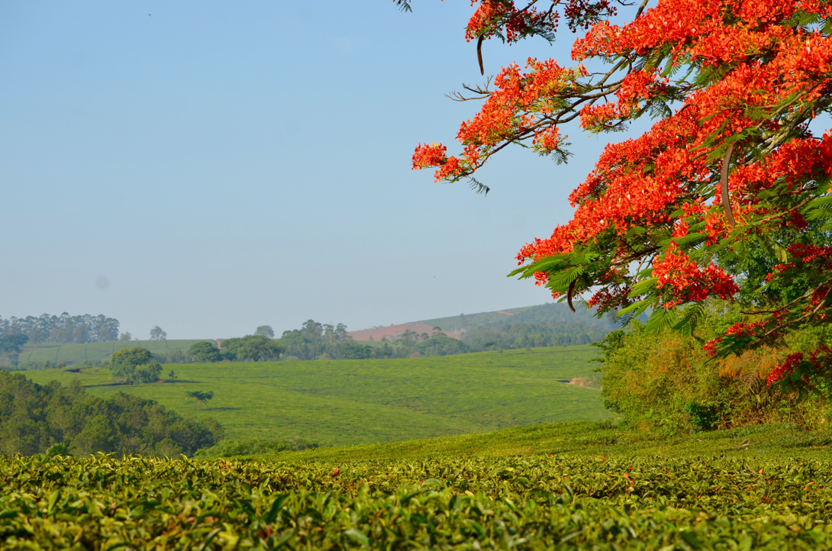
Area and location: Huntingdon House exudes a colonial charm and unique character that cannot be recreated. This magnificent house forms the heart of Satemwa Tea Estate and is surrounded by sprawling manicured gardens with secret patios and terraces waiting to be discovered by guests. As one of Malawi’s first land claims registered in 1874, Satemwa Tea Estate is undoubtedly among the country’s most respected and established tea and coffee producers.

Activities: As Huntingdon House is conveniently located; day trips to Majete Game Reserve in the Lower Shire Valley, Zomba Plateau, Blantyre or Mulanje can easily be arranged. In addition, in-house activities on offer include tea-tasting, mountain biking, coffee tours, walking trails, birding, croquette and other sporting facilities.
Accommodation: The house has been tastefully refurbished to offer 5 unique suites, each individually decorated to reflect the quirks and character of this grand residence. Each area of the house has a story of its own from the original children’s nursery to the resident priest’s quarters and private Chapel. The suites consist of superb bathrooms featuring clawed bathtubs, separate showers, bath robes, wonderful bamboo cotton blend towels and rounded off with a range of guest amenities. The majority of rooms have king size beds with 100% cotton linen and a selection of pillows to ensure that guests enjoy a good night’s sleep.
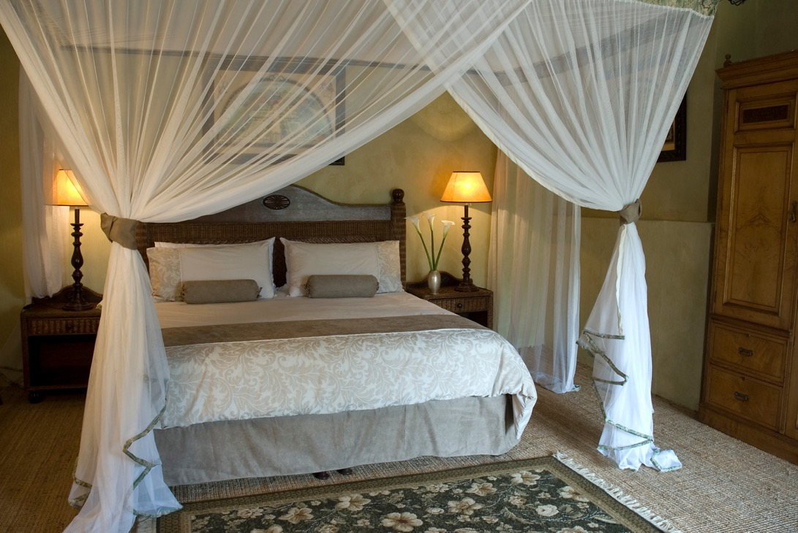

DAYS FIVE AND SIX
During these two days you can rest at leisure, explore the unique character and landscapes of Satemwa, as well as enjoy various activities on offer.

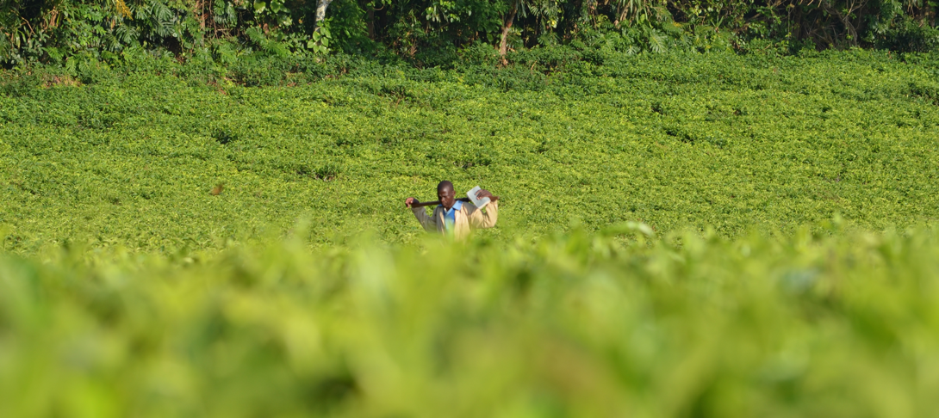

DAY SEVEN
After breakfast you will travel three hours by road south to Mkulumadzi and enjoy a tour of the bustling Blantyre Town on the way.
Area and location: Located in the south of Malawi, Majete is an area of 70.000 hectares, part of Africa’s Great Rift Valley. The reserve is made up of mature miombo woodlands and granite topped hills that contrast with picturesque river valleys and lush riverine forest. For connoisseurs of wildlife many exciting encounters lie in store, with the chance to view many species including black rhino, leopard, lion, elephant, buffalo, eland, kudu, sable, suni, klipspringer, Lichtenstein’s hartebeest and zebra.
Majete Wildlife Reserve is one of the outstanding success stories of African conservation. A concerted joint effort since 2003 by the African Parks Network and the Malawi government - including the reintroduction of endangered species - has turned it into a model of sustainable development and biodiversity. In 2012 Majete became Malawi’s only Big Five Park.
Accommodation: Surrounded by 7,000 hectares of private concession, Mkulumadzi enjoys an idyllic location at the confluence of two rivers shaded by giant Leadwood trees. It is the perfect combination of splendid isolation and first-class facilities. The lodge has eight superb chalets, each with spacious living quarters and private viewing decks.
DAYS EIGHT AND NINE
During these two days, you will have the opportunity of exploring the extremely diverse wildlife and unique landscapes of Majete Wildlife Reserve, as well as enjoy other activities on offer.
Activities: Majete is a true wilderness where every trip into the bush with our team of experienced guides will feel like an adventure. Guests can enjoy a relaxing dip in the pool, dine under the stars, enjoy river cruises, game drives and walking safaris, boat safaris, viewing hides, as well as unforgettable cultural experiences by visiting nearby villages and community centers.
DAY TEN
After breakfast, you will be transferred north to the Kayak Base Camp and you will be able to take a short boat ride to Mumbo Island. The drive to the camp is four hours long, on smooth and picturesque terrain.

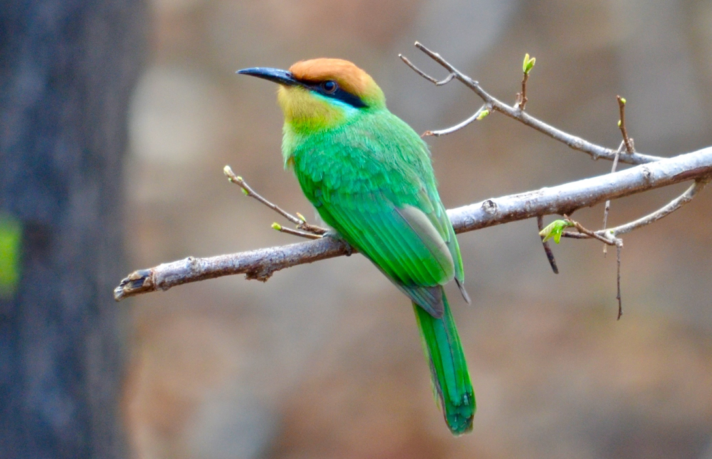
Area and location: Mumbo is a deserted island 10 kilometres off the Cape Maclear Peninsula. The waters surrounding the island are part of Lake Malawi National Park, the world’s first freshwater park, which is also a UNESCO World Heritage Site.
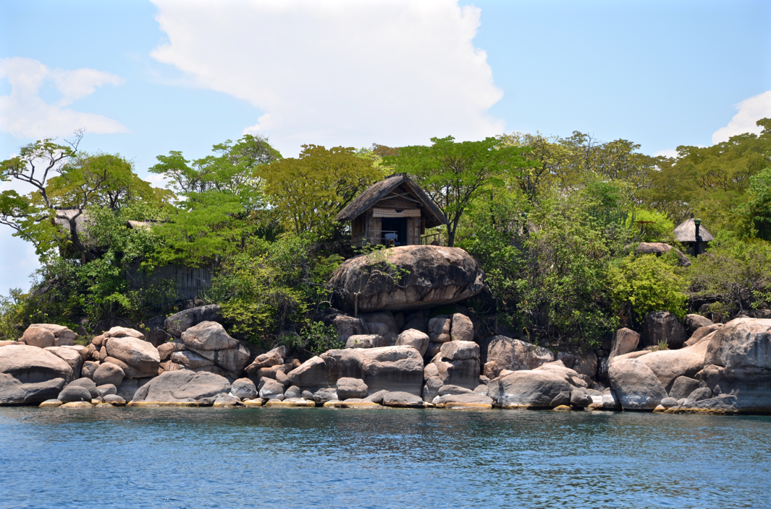
The site and is well known for its diverse populations of cichlids and other freshwater fish. The island itself has never been populated and is covered in miombo woodlands as well as ancient fig and baobab trees.
Accommodation: Accommodation at Mumbo Island features tastefully furnished tents and family units with shaded decks, hammocks, en-suite hot bucket showers and ‘eco-loos’. The camp’s construction adheres to the strictest principles of eco-architecture and its operations make an almost zero ecological impact on the island.
Activities: On the first day of your visit, you can unwind in your room, which is equipped with a hammock and private deck, or relax in the spacious main lounge which overlooks the lake. You can also opt to go snorkelling or canoeing at your leisure as all gear is provided for guests to use whenever they please. Meals can be enjoyed in the main dining area or on the beach. Other activities on offer include birding, hiking and scuba diving.
DAYS ELEVEN AND TWELVE
You will spend these two days discovering and exploring Mumbo Island and you will be able to enjoy a variety of activities at your leisure.
DAY THIRTEEN
After breakfast, you will be transferred to Lilongwe International Airport. The drive is approximately five hours by road and you will arrive in time for your international flight home.
This tour includes: All accommodation and meals, with packed lunches on transfers when necessary; all activities as specified; all park entry fees; all road transfers; local beers, wines and soft drinks at Mkulumadzi.
This tour excludes: Drinks, except as specified at Mkulumadzi; visa fees and a 1% tourism levy.
You can extend this itinerary to include more areas of Malawi or fly to Zambia for a complete contrast!

TRACKS SAFARIS – WE GET YOU CLOSER TO MALAWI!



