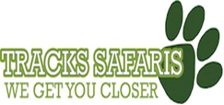

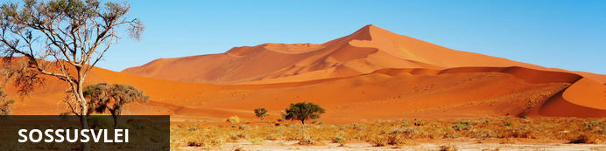

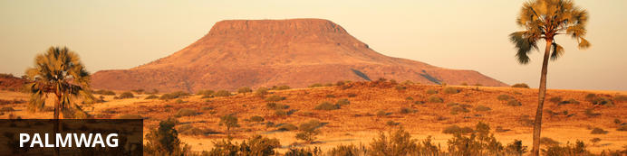

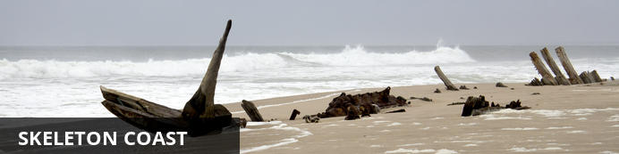

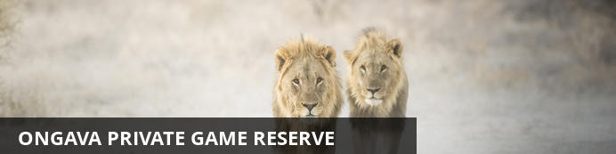

# Tracks Safaris

*Sossusvlei - Palmwag - Skeleton Coast - Ongava Private Game Reserve*  
*13 Days / 12 Nights*

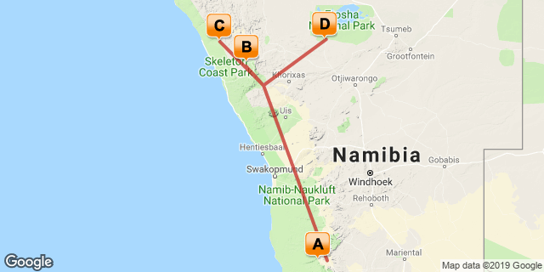

## Introduction

3 nights at Kulala Desert Lodge

3 nights at Desert Rhino Camp

3 nights at Hoanib Skeleton Coast Camp

3 nights at Ongava Lodge

|  |  |  |  |  |  |  |
| --- | --- | --- | --- | --- | --- | --- |
| **Accommodation** | **Destination** | **Start** | **End** | **Basis** | **Room Type** | **Duration** |
| [Kulala Desert Lodge](https://wetu.com/iBrochure/7008_1520) | Sossusvlei |  |  |  | 1x Kulala/s | **3 Nights** |
| [Desert Rhino Camp](https://wetu.com/iBrochure/7008_8725) | Palmwag |  |  |  | 1x Tented Room/s | **3 Nights** |
| [Hoanib Skeleton Coast Camp](https://wetu.com/iBrochure/7008_28944) | Skeleton Coast |  |  |  | 1x Tented Room/s | **3 Nights** |
| [Ongava Lodge](https://wetu.com/iBrochure/7008_8002) | Ongava Private Game Reserve |  |  |  | 1x Chalet/s | **3 Nights** |

## Day 1-4: Kulala Desert Lodge, Sossusvlei

### Sossusvlei

Located in the scenic Namib-Naukluft National Park, Sossusvlei is where you will find the iconic red sand dunes of the Namib. The clear blue skies contrast with the giant red dunes to make this one of the most scenic natural wonders of Africa and a photographer's heaven. This awe-inspiring destination is possibly Namibia's premier attraction, with its unique dunes rising to almost 400 metres-some of the highest in the world. These iconic dunes come alive in morning and evening light and draw photography enthusiasts from around the globe. Sossusvlei is home to a variety desert wildlife including oryx, springbok, ostrich and a variety of reptiles. Visitors can climb 'Big Daddy', one of Sossusvlei’s tallest dunes; explore Deadvlei, a white, salt, claypan dotted with ancient trees; or for the more extravagant, scenic flights and hot air ballooning are on offer, followed by a once-in-a-lifetime champagne breakfast amidst these majestic dunes.

### Day Itinerary

Day 1

Flight from Hosea Kutako International Airport (Windhoek) to Geluk Airstrip  
Transfer by Road - Geluk Airstrip - Kulala Desert Lodge  
Arrive at Kulala Desert Lodge

### Overnight: Kulala Desert Lodge [View iBrochure](https://wetu.com/iBrochure/7008_1520)

Kulala Desert Lodge’s location at the foot of the majestic Sossusvlei dunes allows for stunning views in every direction, while its private entrance to the Namib Naukluft National Park makes it the closest location to Sossusvlei. The camp is ideal for self-drives and groups.

Twenty-three thatched ‘kulalas’ (including two family units) on raised platforms make for airy, comfortable accommodation, and guests can even sleep out on the flat roofs. Afternoons around the pool provide relief from the heat, while the wraparound veranda at the main area overlooks a waterhole, and private tours of the dunes provide the ultimate Sossusvlei experience.

INSIDER'S TIP: Try your hand at desert photography – whether capturing the red colour of the dunes in the early morning light or the otherworldly tree skeletons standing starkly across the floor of Dead Vlei.

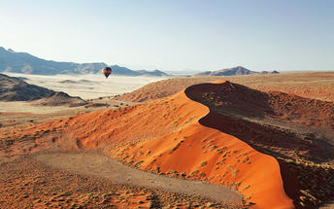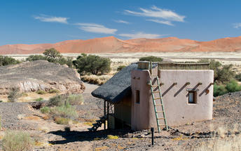

### Flight Information

|  |  |  |  |  |  |  |  |  |
| --- | --- | --- | --- | --- | --- | --- | --- | --- |
| **Date** | **Flight** | **Airline** | **Departure Airport** | **Time** | **Arrival Airport** | **Time** | **Class** | **Ref** |
|  | Scheduled | Wilderness Air Namibia | Hosea Kutako International Airport [WDH] |  | Kulala Airstrip |  |  |  |

### Included

All meals, twice daily scheduled camp activities, park fees, laundry, Namibian VAT & Tourism Levy, and local drinks excludes premium imported brands and champagne.

## Day 4-7: Desert Rhino Camp, Palmwag

### Palmwag

Palmwag is a nature reserve idyllically located along a palm-lined tributary of the Uniab River. Water is scarce in this area, so the river’s presence often lures elephants closer to the camps. Palmwag is situated halfway between Swakopmund and Etosha, and is the ideal base from which to see the sights of the Kunene region or embark on one of the many local hiking trails. The reserve is notable for its unusual species of palm tree, the hyphaena pertesiana, and for being home to the largest population of south-western black rhinos in Africa. Animal lovers can also get a peek at leopard, lion, cheetah, mountain zebra, Angolan giraffe, springbok, kudu, and African bush elephant.

### Day Itinerary

Day 4

Depart from Kulala Desert Lodge  
Transfer by Road - Kulala Desert Lodge - Geluk Airstrip  
Flight from Geluk Airstrip to Doro Nawas Airstrip   
Flight from Doro Nawas Airstrip to Desert Rhino Airstrip  
Transfer by Road - Desert Rhino Airstrip - Desert Rhino Camp  
Arrive at Desert Rhino Camp

### Overnight: Desert Rhino Camp [View iBrochure](https://wetu.com/iBrochure/7008_8725)

Desert Rhino Camp offers an original, exclusive wilderness experience and the possibility of seeing some of the largest free-ranging population of desert-adapted black rhino in Africa. The desert plains – transformed overnight by summer rains – are starkly scenic, and home to other unique species, from Hartmann’s zebra, lion and giraffe to the bizarre welwitschia plant.

The camp consists of eight comfortable Meru-style tents with en-suite bathrooms, and shady main area with refreshing plunge pool. Run in conjunction with Save the Rhino Trust, Desert Rhino Camp offers rhino tracking by vehicle and on foot with experts from this conservation NGO.

INSIDER'S TIP: Explore this extraordinary landscape in search of desert-adapted wildlife and gain amazing insight into the ecology and conservation of this area. A picnic lunch is the perfect complement to your day’s outing!

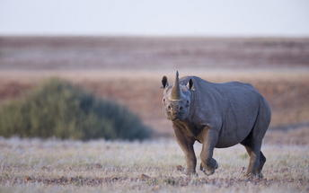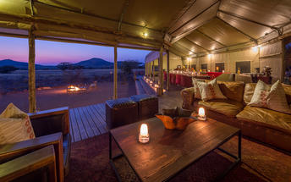

### Flight Information

|  |  |  |  |  |  |  |  |  |
| --- | --- | --- | --- | --- | --- | --- | --- | --- |
| **Date** | **Flight** | **Airline** | **Departure Airport** | **Time** | **Arrival Airport** | **Time** | **Class** | **Ref** |
|  | Scheduled | Wilderness Air Namibia | Kulala Airstrip |  | Doro Nawas Airstrip |  |  |  |
|  | Scheduled | Wilderness Air Namibia | Doro Nawas Airstrip |  | Palmwag Rhino Camp Airstrip |  |  |  |

### Included

All meals, twice daily scheduled camp activities, park fees, laundry, Namibian VAT & Tourism Levy, and local drinks excludes premium imported brands and champagne.

## Day 7-10: Hoanib Skeleton Coast Camp, Skeleton Coast

### Skeleton Coast

Stretching from the Swakop River to southern Angola, the Skeleton Coast is known as the 'Land God Made in Anger' and is remoteness at its best. Thousands of miles of sandy desert dotted with shipwrecks meet with the cold waters of the Atlantic and somehow an amazing array of wildlife and flora manages to survive in this harsh but beautiful environment. Ocean fog creeps over the shoreline caused by the warm dry air of the Namib Desert colliding with the cold Benguela current. This otherworldly area is home to a diversity of wildlife including seabird colonies, Cape fur seals, zebra, gemsbok, desert-adapted elephant, lion and much more. Surfing enthusiasts are drawn to these powerful waves and photographers flock from around the globe to snap a shot of this eerie shipwreck graveyard and for the unrivalled maritime photographic opportunities. This coast is desolate but breathtakingly beautiful.

### Day Itinerary

Day 7

Depart from Desert Rhino Camp  
Transfer by Road - Desert Rhino Camp - Desert Rhino Airstrip  
Flight from Desert Rhino Airstrip to Doro Nawas Airstrip   
Flight from Doro Nawas Airstrip to Hoanib Skeleton Coast  
Transfer by Road - Hoanib Skeleton Coast - Hoanib Skeleton Coast  
Arrive at Hoanib Skeleton Coast Camp

### Overnight: Hoanib Skeleton Coast Camp [View iBrochure](https://wetu.com/iBrochure/7008_28944)

The name “Skeleton Coast” conjures up romantic images of desolate beauty, and proudly remote Hoanib in the Kaokoveld does not disappoint. The dry bed of the Hoanib River supports a thin green ribbon of vegetation and the wild beaches of the Atlantic coast are within reach, with their noisy seal colonies and eerily quiet shipwreck remnants.

Eight large en-suite tents (including one family unit) and the main area provide shady viewpoints, while nature drives into the surrounding area reveal a wealth of desert-adapted wildlife. Desert-adapted lion and brown hyaena may also be glimpsed in this vast but far from lifeless landscape.

INSIDER'S TIP: Take a drive down to the Skeleton Coast and a scenic flight back to camp to see such a diverse area both on the ground and in the air.

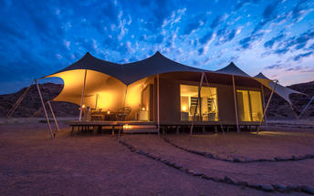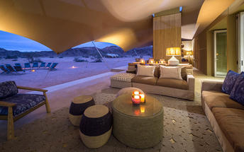

### Flight Information

|  |  |  |  |  |  |  |  |  |
| --- | --- | --- | --- | --- | --- | --- | --- | --- |
| **Date** | **Flight** | **Airline** | **Departure Airport** | **Time** | **Arrival Airport** | **Time** | **Class** | **Ref** |
|  | Scheduled | Wilderness Air Namibia | Palmwag Rhino Camp Airstrip |  | Doro Nawas Airstrip |  |  |  |
|  | Scheduled | Wilderness Air Namibia | Doro Nawas Airstrip |  | Hoanib Skeleton Coast Airstrip |  |  |  |

### Included

All meals, twice daily scheduled camp activities, park fees, laundry, Namibian VAT & Tourism Levy, and local drinks excludes premium imported brands and champagne. On a stay of 3 nights or more at Hoanib Skeleton Coast, a coastal excursion to the Skeleton Coast is included (applicable to our standard and long stay rates only).

## Day 10-13: Ongava Lodge, Ongava Private Game Reserve

### Ongava Private Game Reserve

Sharing the southern boundary with Etosha National Park, the prolific 30 000-hectare private Ongava Game Reserve is considered one of the top private game reserves in the region, enjoying global recognition for exceptional conservation, groundbreaking research and exciting safari experiences. The landscape is characterised by vast open plains dotted with salt plans and abundant wildlife. Visitors can easily access Etosha through Andersson’s Gate in the south. Known for its luxury lodges made out of natural materials, Ogava is a popular destination for those looking to immerse themselves in nature. The reserve offers visitors the perfect combination of wildlife safari experiences within and around the Etosha National Park. One of Ongava’s top attractions is its rhino population and guests can experience the thrill of getting close to these majestic creatures. Popular activities include: night game drives, guided nature walks, bird watching and 4x4 guided game drives.

### Day Itinerary

Day 10

Depart from Hoanib Skeleton Coast Camp  
Transfer by Road - Hoanib Skeleton Coast - Hoanib Skeleton Coast  
Flight from Hoanib Skeleton Coast to Doro Nawas Airstrip   
Flight from Doro Nawas Airstrip to Ongava Airstrip  
Transfer by Road - Ongava Airstrip - Ongava Lodge  
Arrive at Ongava Lodge

### Overnight: Ongava Lodge [View iBrochure](https://wetu.com/iBrochure/7008_8002)

Ongava Lodge is one of Namibia’s premier lodges on one of the country’s most important private game reserves.  
The well-established Ongava Lodge is situated in the privately owned Ongava Game Reserve along the southern boundary of Etosha National Park. Placed as it is close to the top of a hill in the foothills of the Ondundozonanandana range, the vantage point is beautiful and overlooks a well-frequented waterhole and the plains beyond.

Ongava Lodge offers luxury accommodation in 14 rock-and-thatch en-suite chalets. There are impressive views over the camp’s waterhole from the main lounge and dining areas and there is also an inviting pool to cool off in the heat of the day. Meals are either served in the main dining area under thatch or on the dining deck under the stars.

Activities include game drives into Etosha, spending time in the camp hide, and nature drives and walks on the reserve. Ongava has resident white and black rhino, giving guests staying at Ongava the opportunity to see both species.

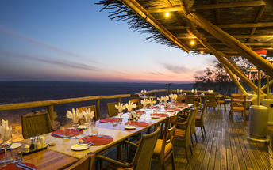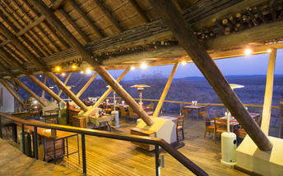

### Flight Information

|  |  |  |  |  |  |  |  |  |
| --- | --- | --- | --- | --- | --- | --- | --- | --- |
| **Date** | **Flight** | **Airline** | **Departure Airport** | **Time** | **Arrival Airport** | **Time** | **Class** | **Ref** |
|  | Scheduled | Wilderness Air Namibia | Hoanib Skeleton Coast Airstrip |  | Doro Nawas Airstrip |  |  |  |
|  | Scheduled | Wilderness Air Namibia | Doro Nawas Airstrip |  | Ongava Airstrip |  |  |  |

### Included

All meals, twice daily scheduled camp/lodge activities, park fees, local drinks and laundry at camps/lodges which are able to provide this service, Namibian VAT and Tourism Levy excludes premium imported brands and champagne.

## Day 13: End of Itinerary

### Flight Information

|  |  |  |  |  |  |  |  |  |
| --- | --- | --- | --- | --- | --- | --- | --- | --- |
| **Date** | **Flight** | **Airline** | **Departure Airport** | **Time** | **Arrival Airport** | **Time** | **Class** | **Ref** |
|  | Scheduled | Wilderness Air Namibia | Ongava Airstrip |  | Hosea Kutako International Airport [WDH] |  |  |  |