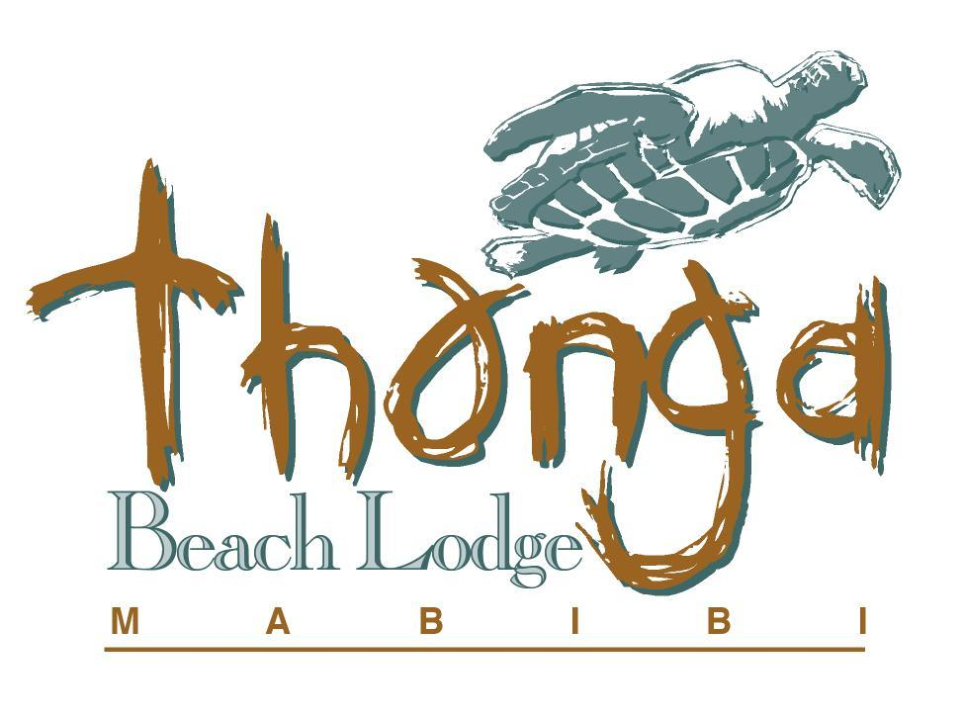

Dive Information at Thonga

Our resident Instructor is PADI trained and certified and is able to offer a variety of courses to suit your individual requirements and get you breathing underwater and exploring the spectacular coral reefs at Thonga.

Diving at Thonga has been rated by seasoned divers to be world class. This coastline is typically verged by a continental shelf stretching for about three to five kilometres out to sea, before giving way to deeper, abyssal waters, but the shallow shelf immediately offshore is cut through by several canyon like reefs, relics of riverine erosion from a time when the ocean level was lower than it is today.

Diving is weather and tide dependant, as these affect boat launchings and at times can be cancelled at the last minute. Our Padi trained and certified instructors are passionate about the Indian Ocean and are able to share this infectious love of the sea by taking you to beyond the breakers and below the surface. They also offer a variety of courses to get you there.

Thonga Home Reef – Gogo’s
Gogos is our most exciting and beautiful reef. As it is situated just beyond the backline, right in front of our lodge, it makes the boat ride to this site less than 5 minutes! The name Gogos means ‘Old Woman’ in Zulu and it refers to the old woman Angelfish that swims mid-water above the reef, playing with and biting diver’s bubbles.

The depth ranges from 10 metres to a maximum of 18 metres. Gogos has a combination of a main, solid reef structure with rock and coral outcrops in impressive shapes and formations. Sand patches between the reefs often offer Ray sightings. As if the reef structure isn’t impressive enough, this reef offers a prolific array of fish, not only in numbers but also variety. Then add other sea-life like turtles, shrimps, lobster, anenomies, Tiger Cowries and you can see why a good dive on Gogos is hard to beat.
There is also a resident Potato Bass who’s surprised many of our divers by appearing to emerge from nowhere.

3 Sisters
Offering spectacular big game and reef fish, and situated a little further offshore, the average depth is 16 metres to a maximum of 22 metres. On the northern side of the reef a small ledge starts developing into a wall as we move southwards. It’s a good idea to bring a dive torch along, as there are several deep caves and crevices where moray eels, different type of shrimp and other interesting sealife are frequently spotted. Further south the wall fades to a steep slope and the sandy bottom is replaced by more reefs with plenty of interesting hiding places. A cloud of Yellow Banded Snapper usually hovers at the base of the slope.

Higher up the incline are more caves with anything from Lobster to Lionfish present. On the south side the slope gradually fades out again to a flat reef.

Waterworld
This very exciting reef offers spectacular coral reef, canyons and swim-throughs. Waterworld is situated only a couple of hundred metres from the shore and starts at a depth of 7 metres with a maximum depth of 14 metres. From the minute we roll over and descend down to the reef it feels like an amusement park. Swimming down the canyons, there is coral splashed out on the walls, which goes up and over into the next cove and canyon.

For the experienced diver, there is a pair of swim-throughs, guarded by Chubs and Baardman.

This reef is covered in pristine coral. Because of the depth, this underwater playground seems to attract a lot of juvenile fish of all species. Brightly coloured Fusiliers often swim over in mid-water. Turtles are plentiful and can often be seen sleeping in caves or heading up to the surface for some fresh air. The sighting of a Regal Angel is also possible. However, this dive is more suitable in calm sea conditions.

Dive Costs at Thonga
1st Scuba Diving excl Equipment | R 460 per person
2nd Dive and all dives thereafter | R 410 per person
Dives include cylinder & weight belt. Exclude other diving equipment, Full Gear R245, R60 per item per day

Dive Courses Available at Thonga

Pre-Entry Level
Bubble Maker R 375 pp
This course is for the kids and a great way to keep them busy whilst you enjoy the peace and tranquillity at Thonga. A great introduction to scuba, this course takes place in the swimming pool, using scuba equipment and just allows them to play around under close supervision of an instructor. The course is open to anyone 8 years of age or older.

Discover Scuba R 375 pp
This course will introduce you to the enjoyment of breathing underwater. Conducted entirely in the swimming pool, it’s a great way to overcome any initial misgivings. The course is open to anyone 10 years of age or older. This course may count towards your Open Water Dive qualification.

Discover Scuba Diving R 1, 050 pp
This course is our most popular. It is ideal for guests who do not have time on their hands to do a full certification course, but would still like to explore the wonders beneath the ocean at Thonga. Discover Scuba Diving will allow you to dive to 12m under the close supervision of an Instructor. This is perfect, as some of our best reefs are at 12m and shallower. (This is not a qualification course – once you leave Thonga you are NOT qualified to dive anywhere else, but it does count towards your Open Water Diver qualification). Usually this course can be done in one day; however it is advisable to allow for two due to varying tides and weather conditions. Open to anyone over 12 years of age.
Includes: 1-2 hour pool training and 1 x Ocean Dive

Entry Level

Scuba Diver R 3,450 pp
This three day course is ideal for guests who would like to get a dive certification but don’t have time to do the full open water course. These dives count towards your Open Water Diver qualification. This qualification certifies you to dive up to 12m with an Instructor. This is perfect, as some of our best reefs are at 12m and shallower. Open to anyone over 12 years of age.
Includes: Crew pack with dive tables, pic cards, log book and dive book, dive theory, pool training and 2 x ocean dives

Open Water Diver (& Junior Open Water Diver) R 4,650 pp
At least four days and five nights is required for this course. It will give you a full open water diving certification and allows you and your buddy to dive independently to a depth of 18m. This course is recommended to all those that would like to start diving regularly and is recognized internationally. Open to anyone over 12 years of age.
Includes: Crew pack with dive tables, pic cards, log book and dive book, dive theory, pool training and
4 x ocean dives

Open Water Referrals R 3,400 pp
For those people who want to do the full open water certification course but who do not want to spend their time at Thonga studying dive theory and in the pool, we recommend you do all your training at home and then just bring along all the relevant documents. We will then do your 4 x open water dives at Thonga. Remember, you will have to do your training with a PADI instructor.
Includes PIC card and 4 x ocean dives

Refresher R 480 pp
For those who have not dived for a while, we recommend that you do a refresher course with us to refresh your diving skills before taking the plunge into the ocean again.

Continuing Education
Advanced Open Water Diver (& Jr Ad Open Water Diver) R 3,400 pp
This qualification provides the qualified diver with additional experience through a structured, well-supervised course and will allow you to dive up to depths of 30m. There are two mandatory dives, the Deep Diver and the Navigation Diver and 3 elective dives.

At Thonga Beach Lodge Marine Centre we make every effort to ensure that our guests have an awesome experience, but we will not compromise safety and will not take people diving if we feel they are not capable of diving the current conditions. All courses are weather and tide dependant.
All course prices include the relevant study materials and the use of diving equipment during the course.
Please note that Rates will increase in September 2011 Released: 30 Apr 2011

