**9 NIGHT SAFARI TO THE CONGO BASIN**

**RAINFOREST JOURNEY**

**CENTRAL AFRICAN REPUBLIC**

Enjoy a phenomenal week in the Dangha-Sangha Reserve with a range of amazing and immersive activities led by both lodge and park guides. We recommend Ethiopian Airways for your flight to Bangui and the flights fit our itinerary perfectly. Your adventure into the second largest rainforest in the world begins on your arrival into Bangui, the capital of the Central African Republic, where you will be met at the airport and transferred The Ledger Hotel for one night. The dates below are totally flexible and are given as an example only.

We have built in a night at both the ends of your Rainforest Journey as experience tells us that even the best laid plans sometimes go wrong and it is possible to miss your light aircraft flight going in to the rainforest, or your international flight on the way out. Tracks Safaris are ATOL bonded and members of the Travel Trust Association offering you 100% financial protection and peace of mind. We are happy to package your safari and international flights to form an ATOL bonded package – please ask!

This 9-night adventure will ignite all your senses as you discover different aspects of immersing yourself in the rainforest for a 7 days – you will push your boundaries physically and engage with local cultures and with the fauna and flora of this remote, challenging but stunningly beautiful environment. The beauty of this trip is that you will have a very comfortable base from which to set out every morning and return to after your rainforest experiences with a lovely wooden banda with proper bed, ensuite bathroom and veranda overlooking the river.

**DAY ONE**

Depart London Heathrow with Ethiopian Airlines flight ET0701 departing at 2015 and arriving into Addis Ababa at 0700 the next day. Guests arriving from different countries can link in Addis Ababa.

**DAY TWO**

You are in transit until you board your Ethiopian Airlines flight ET0959 departing at 1000 and arriving into Bangui at 1140. On arrival you will be met by our representative and assisted to purchase your entry visa and complete entry procedures, collet your luggage, and make your way out of the arrival hall where you will be transferred to the Ledger Hotel for one night on a bed and breakfast basis.

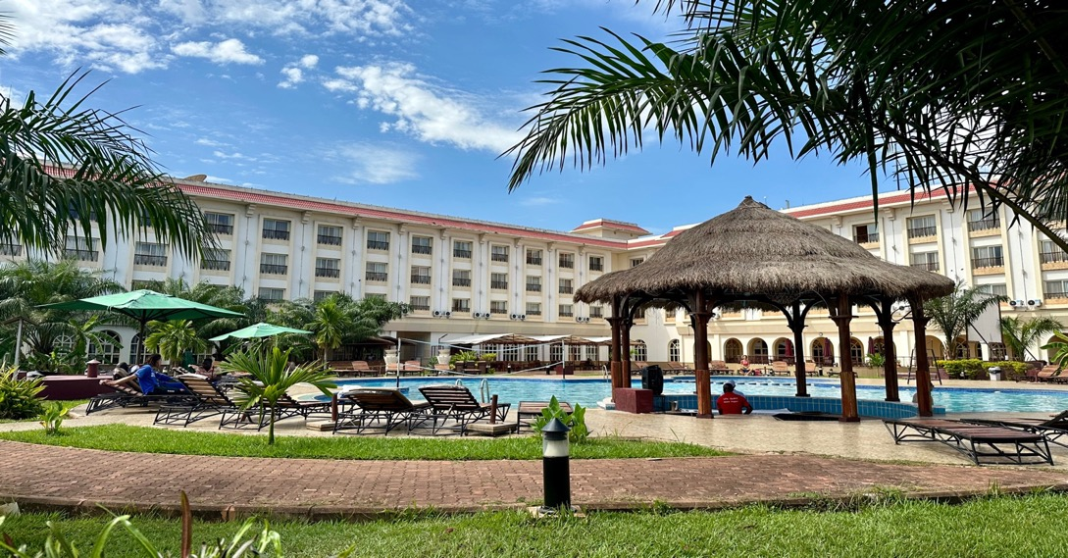

The rest of the day is at leisure at the Ledger Hotel which has air-conditioning, a swimming pool and a reasonable restaurant/bar area.

**DAY THREE**

You will be met at the hotel and transferred back to the airport in time for your light aircraft flight to Dzanga-Sangha. The flight takes just over an hour, and you are flying over dense rainforest for most of your flight. On the approach to the airstrip, you may have the chance of seeing Dzanga Bai from the air as you approach the mud airstrip across the Sangha River. Once landed you will be met and transferred to Sangha Lodge set in a concession bordering the park and overlooking the Sangha River - roughly 45 minutes’ drive away. If time permits, you will venture out in the afternoon to explore the forest, followed by a short afternoon sundowner cruise on the Sangha River.

**DAY FOUR**

After a hearty breakfast, it's time to visit Dzanga Bai! This large clearing in the middle of the rainforest is where forest elephants gather in large numbers to indulge in drinking the mineral-rich waters that bubble across the clearing. The interaction between so many different groups of forest elephants is riveting and there's always the possibility of seeing some of the other normally shy forest creature like bongo, giant forest hog, red river hog, sitatunga and forest buffalos as well as exceptional birdlife.

The trip to the bai includes a road journey through the rainforest and you will park the vehicle and walk the last 2 to 3 kilometres fording crystal clear streams, and walking through the forest on well-worn elephant tracks, until you reach the bai and the platform, where you will spend the day watching the wildlife come in and out of the bai. From the platform you can experience elephants digging for minerals, bathing in the mud to cool down and clear parasites, hear the orchestra of elephant vocalisations and witness many social interactions.

You may be joined on the platform by the elephant researchers who are identifying individual elephants and deciphering elephant language and communication.

Enjoy a packed lunch with tea and coffee and snacks on the platform whist watching the animals and then later retrace your steps back to the vehicle, and back to camp in time for dinner and overnight at the lodge.

**DAY FIVE**

Today you will drive to the Primate Research Centre – just over an hour’s drive from the lodge. On the way you may have the chance to see primates and enjoy some birding. On arrival your guide will brief you and you begin your hike to see habituated Mangabey monkeys. Be prepared for a long hike to reach these fascinating primates as they can move quite quickly. Other times the monkeys can be found moments from the research centre – each day is different.

On locating the group of agile mangabey monkeys, you can spend some time watching and photographing and their interesting antics. This group of habituated monkeys has more than 150 members and their fascinating behaviour is part of a long-term study in the region.

You will take a packed lunch with you and return to the lodge later in the afternoon. The rest of the day is free – you can enjoy walking along the forest paths around the lodge, or perhaps take a kayak out on the river at the end of the day. Dinner and overnight at Sangha Lodge.

**DAY SIX**

Following breakfast today you will head upriver by boat and hike to a series of waterfalls in the area. The hike takes you through the best examples of prime rainforest in Africa. Apart from the amazingly beautiful waterfalls, you will also see some of the most spectacular trees imaginable. Led by BaAka guides you will have the chance of seeing some amazing wildlife ranging from paraponera clavate - commonly known as the bullet ant with an extremely painful sting – to bats, porcupines, tree squirrels and if you are lucky – a forest pangolin.

Climbing to the top of the falls will provide vistas over the canopy of the forest, while the possibility of seeing the extremely rare and endangered Red-Headed Picathartes (also known as the Grey-Necked Rock Fowl) will excite any birders. Enjoy a cool down in the pools below the falls which will refresh you for the walk back to the boat.

In the evening after dinner, you may do a night walk near the lodge with the hope of finding some of the more elusive nocturnal animals such as potto, Thomas’s galago, tree pangolin, African palm civet, Frazer’s Eagle Owl and the Vermiculated Fishing Owl. Dinner and overnight at Sangha Lodge.

**DAY SEVEN**

Enjoy breakfast overlooking the Sangha River before heading out with a group of BaAka net hunters as they go about their daily hunter-gatherer lifestyle. It's both fascinating and a joy in itself to see how well-adapted and comfortable the BaAka are in the forest. You will be shown several of their medicinal plants while the hunt goes along in the background, and the excited cheers will alert us if they do catch something. Please note that this activity is not contrived. The hunters are there to catch their food so some animals may be killed.

The BaAka will also demonstrate how they make their temporary shelters in the forest, and you will hear their singing during the hunting ceremony. After your cultural rainforest experience you will head back to the village for a walk with your guide to experience village life.

Later head back to the lodge for lunch and free time in the afternoon to sit and enjoy the river, read, kayak or walk the paths around the lodge. Dinner and overnight at Sangha Lodge.

**DAY EIGHT**

It's back into the park today with your park and BaAka guides and picnic lunches, where you will walk around a series of clearings , or bais, in the rainforest. The chance of finding buffalos, elephants, sitatunga and several monkey species on this trek are good and you should be able to observe wildlife on foot.

Today is a great opportunity to enjoy some birding and really enjoy being in the forest. You will see varied flowers and fungi, some amazing insects, and observe butterflies and bees which congregate near the water in the clearings attracted by the minerals - the colours of the different species of butterflies are dazzling.

The drive takes around an hour back to the lodge in time for a shower, dinner and overnight at Sangha Lodge.

**DAY NINE**

Today is a leisure day where you can either relax in and around the lodge or indulge in some optional activities, perhaps revisiting Dzanga Bai or enjoying another hike in the forest. Alternatively, you can enjoy some kayaking on the Sangha River, walking along the several trails the lodge has laid out in the forest around the lodge, or simply relax with a book. Please note that optional activities are not included in the itinerary price and will be for your own account. Dinner and overnight at Sangha Lodge.

**DAY TEN**

Today is departure day - after breakfast you will be drive to the airstrip to take your charter flight back to Bangui where you will be met on arrival and transferred back to the Ledger Hotel for one night on a bed and breakfast basis.

**DAY ELEVEN**

This morning after a leisurely breakfast you will be met at the hotel and transferred back to the airport in time for your Ethiopian Airlines flight ET0958 to Addis Ababa departing at 1340 and arriving at 1900.

**DAY TWELVE**

You are in transit until you board your Ethiopian Airlines flight ET0700 to London Heathrow departing at 0135 and arriving at 0635 the same day.

﻿

* Please note that plans in this remote part of Africa remain flexible as the logistics often dictate, but the above itinerary should run closely along the schedule laid out. There may be further options to enjoy guided night walks or drives in the evening after dinner.

**TRACKS SAFARIS – WE GET YOU CLOSER TO AFRICA!**

