

**10 NIGHT/11 DAY WILDLIFE OF THE NORTHERN PANTANAL**

**A SAFARI TO THE WETLANDS OF CENTRAL BRAZIL**

Enjoy a once in a lifetime journey to the heart of the northern Pantanal – formerly an ancient inland sea and the largest seasonal floodplain on the planet. This journey spotlights the jaguar and we have dedicated 3 nights on a luxury floating hotel in the Porto Jofre area – known for its high concentration and ease of viewing this elusive and shy cat. With multiple sightings every day – this area is busy – but virtually guarantees lots of viewings.

To break the long driving distances, we have also included 3 nights at savanna lodges where you will have the chance of seeing different wildlife – crab eating foxes, armadillo, agouti, brown or grey brocket deer, giant anteater and tapir. You will also have the chance to see ocelot close up using a specialist hide – perfect for photographing this elusive species of cat.

Lastly you will head to the peaceful Paraguay River for 4 nights – close to the Taiama Ecological Reserve. Staying at a remote hotel set on the banks of the river - your wildlife viewing will be with only a few boats on the river each day, allowing you to relax and enjoy the wildlife and birdlife at a slower pace.

Wildlife of the area incudes capybaras, caimans, armadillos, giant anteater, crab eating wolf, marsh and broket deer and the giant river otter. Primates include Azaras’s Capochin, black and gold howler monkey and the black tailed marmoset. In the evenings it is possible to see both the greater and lesser bulldog bat.

Birding at both river and savanna destinations is outstanding with over 580 species recorded in the Pantanal. Highlights include the boat billed heron, jabiru stork, hyacinth macaw, toco toucan, southern screamer, greater rhea, amazon kingfisher, great potoo, white woodpecker, capped heron and red legged seriema – amongst others!

**DAY ONE**

On arrival into Cuiaba, you will be met by our representative at the airport – kindly ensure that your flight arrives before 12 noon as once the group has arrived you will be transferred to a local restaurant for a delicious, hosted buffet lunch at 1pm. An overnight stay in Cuiaba can be arranged if you would prefer.

After lunch, depart Cuiaba at 2pm in an airconditioned vehicle south towards Porto Jofre along the Transpantaneira Road for approximately 3 hours (depending on what you might see along the way – including the marsh deer, greater rhea, caiman, peccaries, and a huge variety of birds). We aim to be at the lodge by 5pm to enjoy the chance to view ocelots using the screened hide – a once in a lifetime opportunity to view and photograph these stunning cats at close quarters. Alternatively, you can view a jabiru stork nest by climbing the observation tower within the grounds of the lodge.

**OVERNIGHT AT THE LODGE – FULL BOARD**

*Located around 2.5 km off the main road on the forested banks of the wildlife rich Pixaim River, the lodge has a large, fully screened living room/dining room with many overhead fans, outdoor sitting areas, and a library on Brazilian nature. Each of the fifteen screened guest rooms has a private, hot-shower bathroom, overhead fans, air-conditioning and one queen or two twin beds and the whole lodge has WIFI. To eliminate plastic bottle waste, the lodge offers complimentary chilled drinking water dispensed in unlimited amounts from dedicated water coolers.*

**DAY TWO**

This morning rise early to enjoy a walk around the lodge viewing the many varieties of birds. After a hearty breakfast depart for Porto Jofre which is around 4 hours by road (depending on what you see).

On arrival into Porto Jofre, you will board a motorboat for a 15-minute transfer to the Jaguar Suites - an airconditioned floating hotel moored on the banks of the Piquiri River – arriving in time for lunch. After check-in you will be shown to your suite – home for the next four nights.

A little later after a rest or siesta you will meet your guide and enjoy your first 4-hour afternoon boat safari in search of jaguar, giant river otters, caiman, capybara and a huge number of birds along the myriad of rivers and channels in the area.

Later in the evening as the sun is setting, return to the Floatel for dinner, an informative lecture on one of the species found in the Pantanal, and overnight.

**OVERNIGHT AT THE JAGUAR SUITES – FULL BOARD**

*Your home for four nights will be a purpose-built, air-conditioned, floating hotel with WIFI, anchored in the middle of an area with the highest known concentration of jaguars with no commuting time – you are straight into the small boats directly from the floating hotel on the 100-meter-wide Piquiri River.*

*Offering some of the best guest rooms in the Pantanal – the 12 spacious suites have four-meter-wide, floor-to-ceiling, sliding glass doors that face the wild forests of the famously-Jaguar-rich, 270,000-acre Meeting-of-the-Waters State Park.*

**DAYS THREE AND FOUR**

You have two full days (in total five x four-hour river safaris) to explore the rivers and channels searching for wildlife and birdlife with lectures in the evening by the Floatel’s naturalist. Each day you will rise early and enjoy a hot breakfast before heading out on the river for 4 hours before returning to the floating suites in time for a buffet lunch. After free time in the early afternoon head off again for another 4 hours on the water, returning to your hotel as the sun sets in time for dinner, evening lecture and overnight.

**OVERNIGHT AT THE JAGUAR SUITES – FULL BOARD**

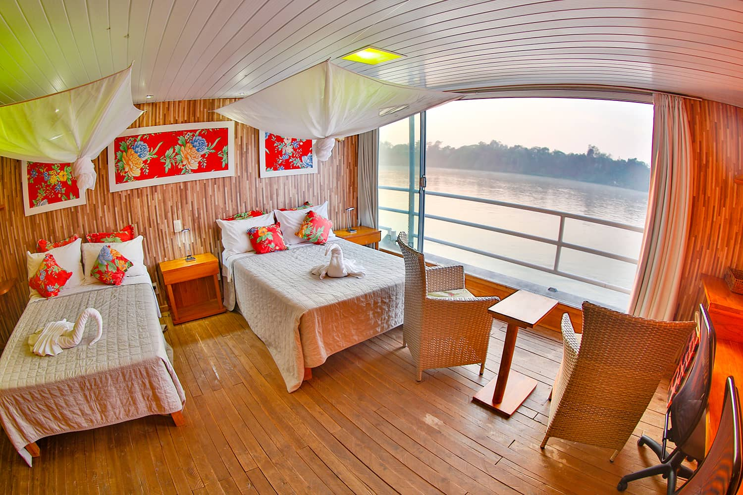

**DAY FIVE**

This morning you will rise early and enjoy breakfast before heading out for a short water safari. Make your way to meet the vehicle and drive back along the Transpantaneira Road for around 4 hours before reaching Araras Lodge, arriving in time for a buffet lunch.

In the afternoon enjoy a jeep safari within the grounds of the lodge, enjoying the huge diversity of birds, mammals and reptiles. Your drive will go on into the early evening and a spotlight should produce nocturnal wildlife with the chance to see ocelot, puma, giant ant eaters, the southern tamandua, the Brazilian rabbit, armadillo, crab eating foxes and possibly, if you are lucky, maned wolf or jaguar.

Drive back to the lodge where you will enjoy a buffet dinner and overnight.

**OVERNIGHT AT ARARAS LODGE ON A FULL BOARD BASIS**

*Set inside the sprawling Pantanal wildlife sanctuary, this laid-back eco lodge is set around 3 km from the main Transpanteria Road and 30 km from Poconé. The lodge has a large dining room and bar, outside seating patios, a covered outdoor dining room and a swimming pool set in gardens. Walking trails lead from the main lodge to the surrounding countryside and the lodge has two observation towers.  
  
Featuring private entrances and screened windows, the air-conditioned guest rooms provide en-suite bathrooms, plus porches with hammocks, overlooking the swimming pool, gardens and ponds surrounding the lodge. Activities such as guided safaris, horseback rides, birdwatching, canoeing and hiking are available at the lodge.*

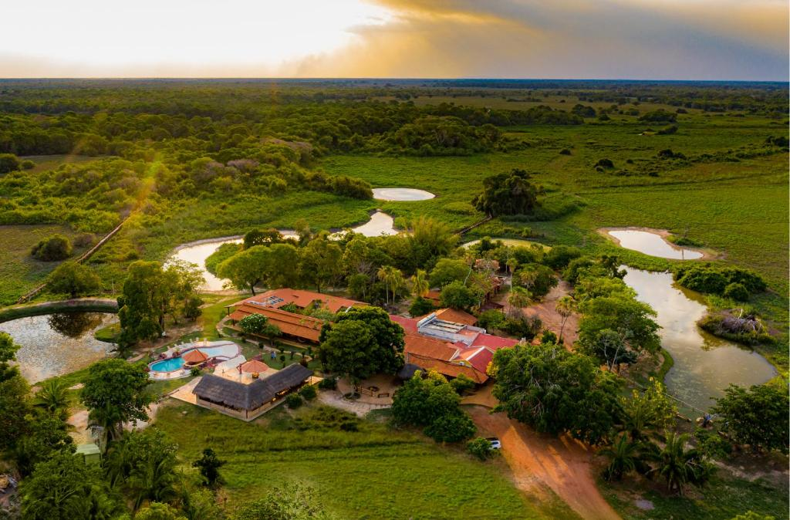

**DAY SIX**

A whole day to discover the savanna areas around the lodge – you can enjoy a morning horse riding, some more birding, discover one of the many walking the trails with a guide, or enjoy a land safari in a specially converted 4 x 4 vehicle. Or simply relax in your hammock with a good book or enjoy a cool off in the lodge’s swimming pool set in wonderful gardens filled with birds.

**OVERNIGHT AT ARARAS LODGE ON A FULL BOARD BASIS**

**DAY SEVEN**

Rising early, enjoy a hearty breakfast before heading off on a walk along one of the lodge’s designated trails in search of a huge variety of birds and mammals before climbing one of the observation towers for a 360-degree view of the area around the lodge.

Return to the lodge for an early buffet lunch before departing for Hotel Baiazinha – around 5 hours driving. You will drive on the Transpantaneira Road towards Pocone and on to Caceres before continuing a further 62 miles on dirt roads through stunning landscape dotted with cattle ranches and farmland, before finally arriving at your last lodge on our Pantanal journey. Hotel Baiazinha is set on the banks of the Paraguay River close to the Taiama Ecological Reserve.

This is a wonderful location to spend the next four days exploring the Paraguay River, coming back to the lodge for meals and overnight. The lodge is set in a remote area and the exploring is peaceful – you might just well be the only boat on the river apart from local fishermen.

Your days are filled with boat safaris along the river in search of jaguars, caimans, capybara and giant river otters and if you do find a jaguar – you are likely to be the only boat to enjoy the sighting. The birdlife is astounding with regular sightings of kingfishers, cormorants, anhinga, ibis, spoonbills, teals, herons, bitterns, egrets, storks, skimmers, terns, lapwings, plovers, vultures and herons.

**OVERNIGHT AT HOTEL BAIAZINHA ON A FULL BOARD BASIS**

*The hotel offers a complete contrast to the busy Porte Jofre area – it has a small private jetty where your boat safaris start and finish, and the hotel is built around a central paved area with a swimming pool and the dining room serving breakfast overlooks the river.*

*The airconditioned, ensuite rooms are set around the central area, simply furnished but comfortable, and there is a table and chairs for each room outside in the corridor. The main restaurant serves a buffet dinner in the evening, made from locally sourced ingredients. Free WIFI is available. Apart from river safaris, you can enjoy horse riding and river fishing.*

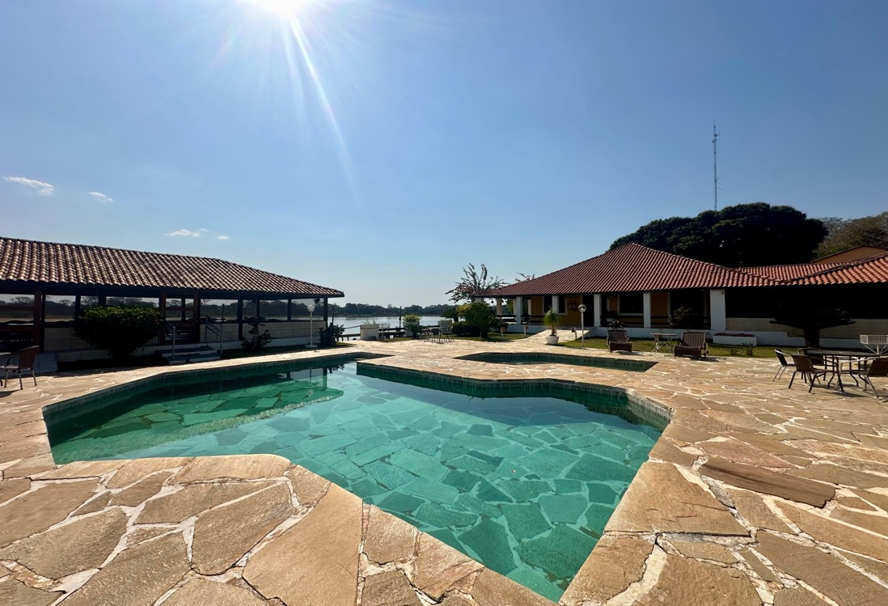

**DAYS EIGHT TO TEN**

Three full days enjoying two x four-hour boat safaris per day exploring the river systems in search of birdlife and wildlife. In your free time in-between lunch and your river safaris you can enjoy a dip in the lodge’s swimming pool or a siesta.

**OVERNIGHT AT HOTEL BAIAZINHA ON A FULL BOARD BASIS**

**DAY ELEVEN**

This morning you will enjoy an early breakfast, departing early from the lodge and driving back to Cuiaba, arriving at the airport around midday. You can either check into your international flight home, enjoy a night in Cuiaba or explore more of Brazil – please ask!

**TRACKS SAFARIS – WE GET YOU CLOSER TO THE PANTANAL IN BRAZIL!**

